**Lab 3**

**Lecture 04**

1) select ename,job,deptno from emp where job= 'CLERK';

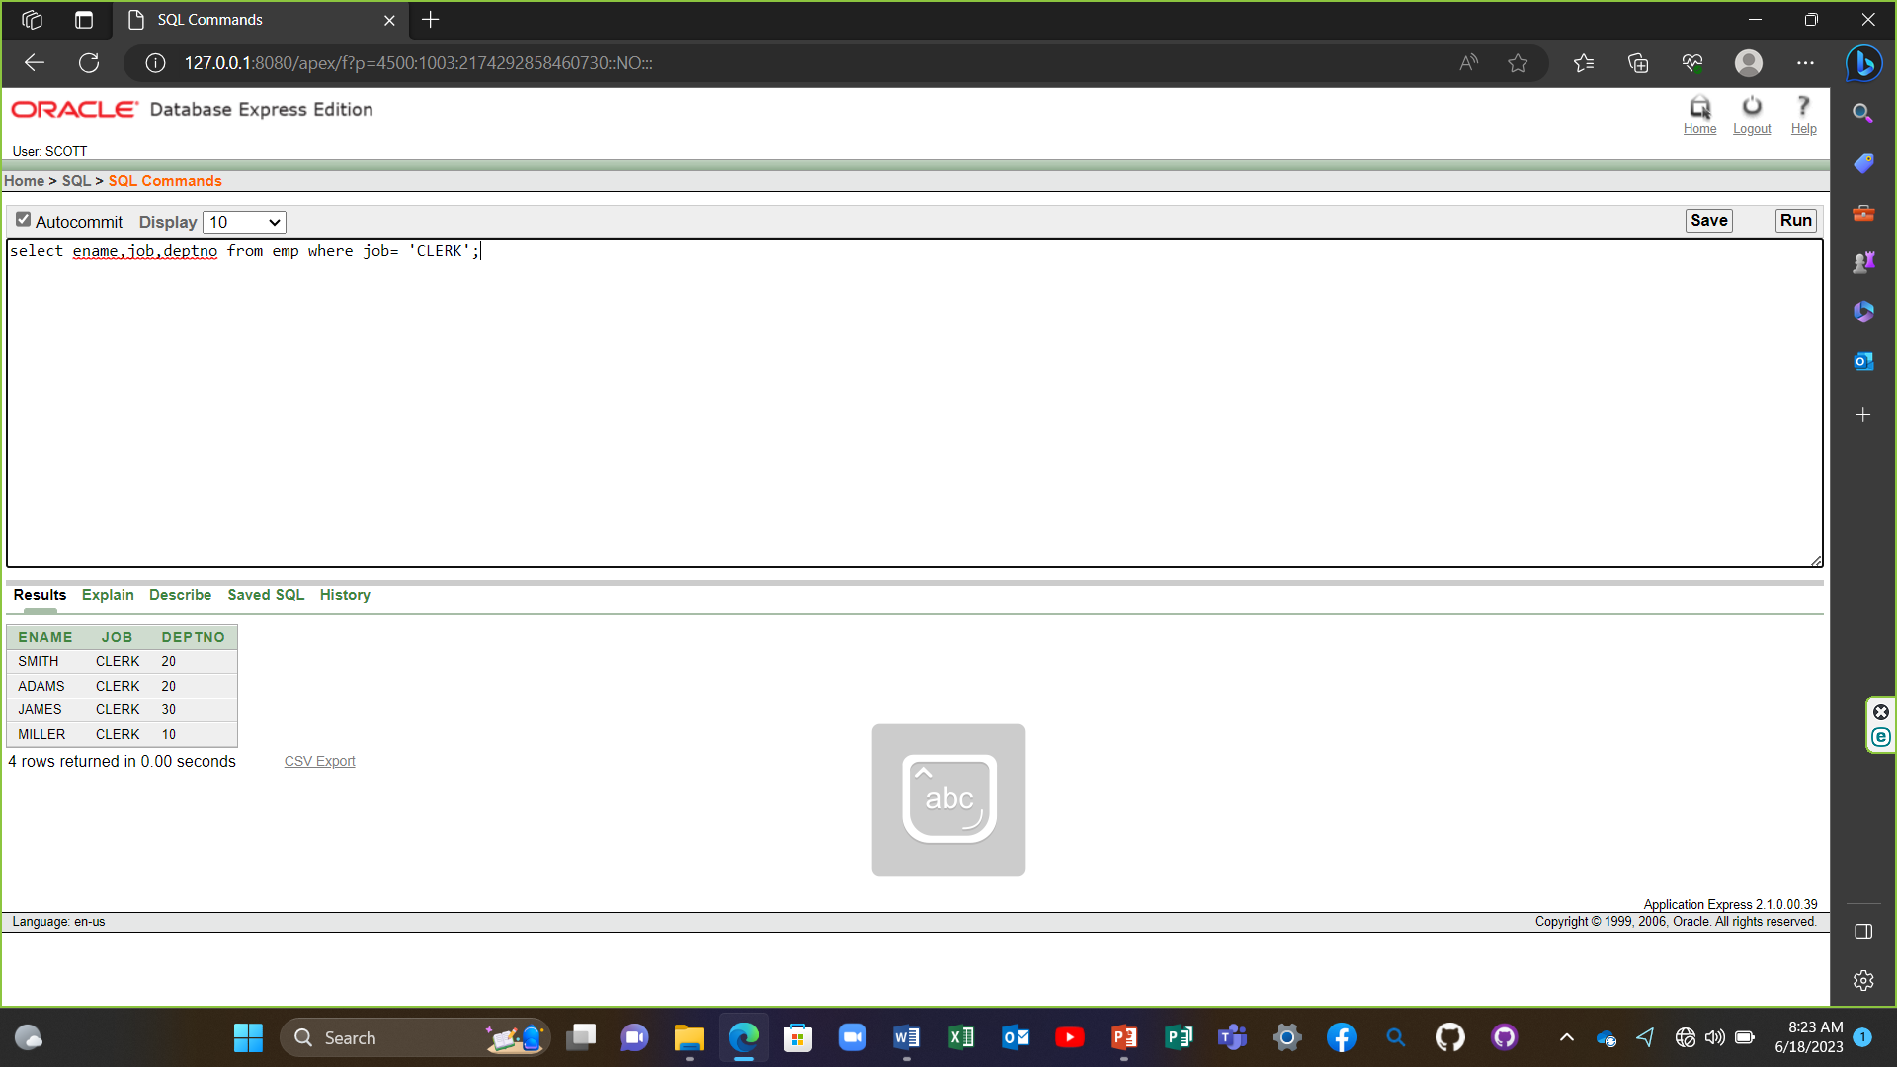

2) select ename,job,deptno from emp where ename='JAMES';

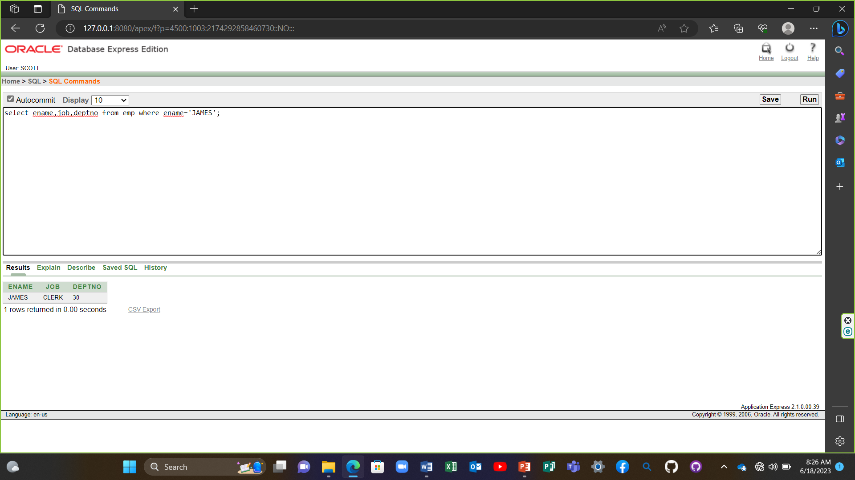

3) select ename,sal,comm from emp where sal<=comm;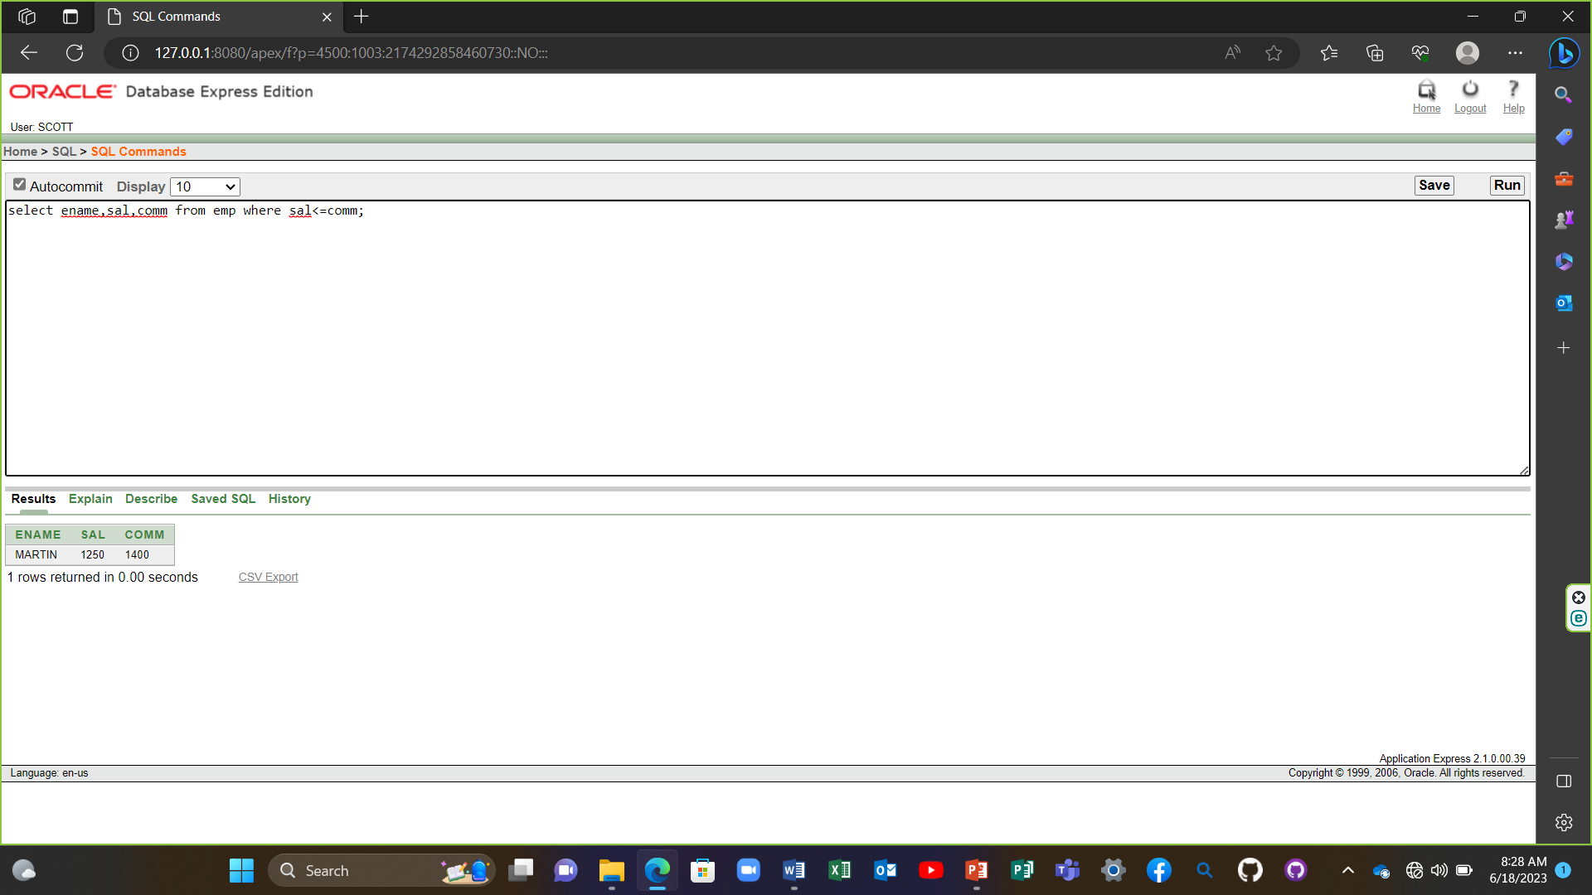

4) select ename,sal from emp where sal between 1000 and 1500;

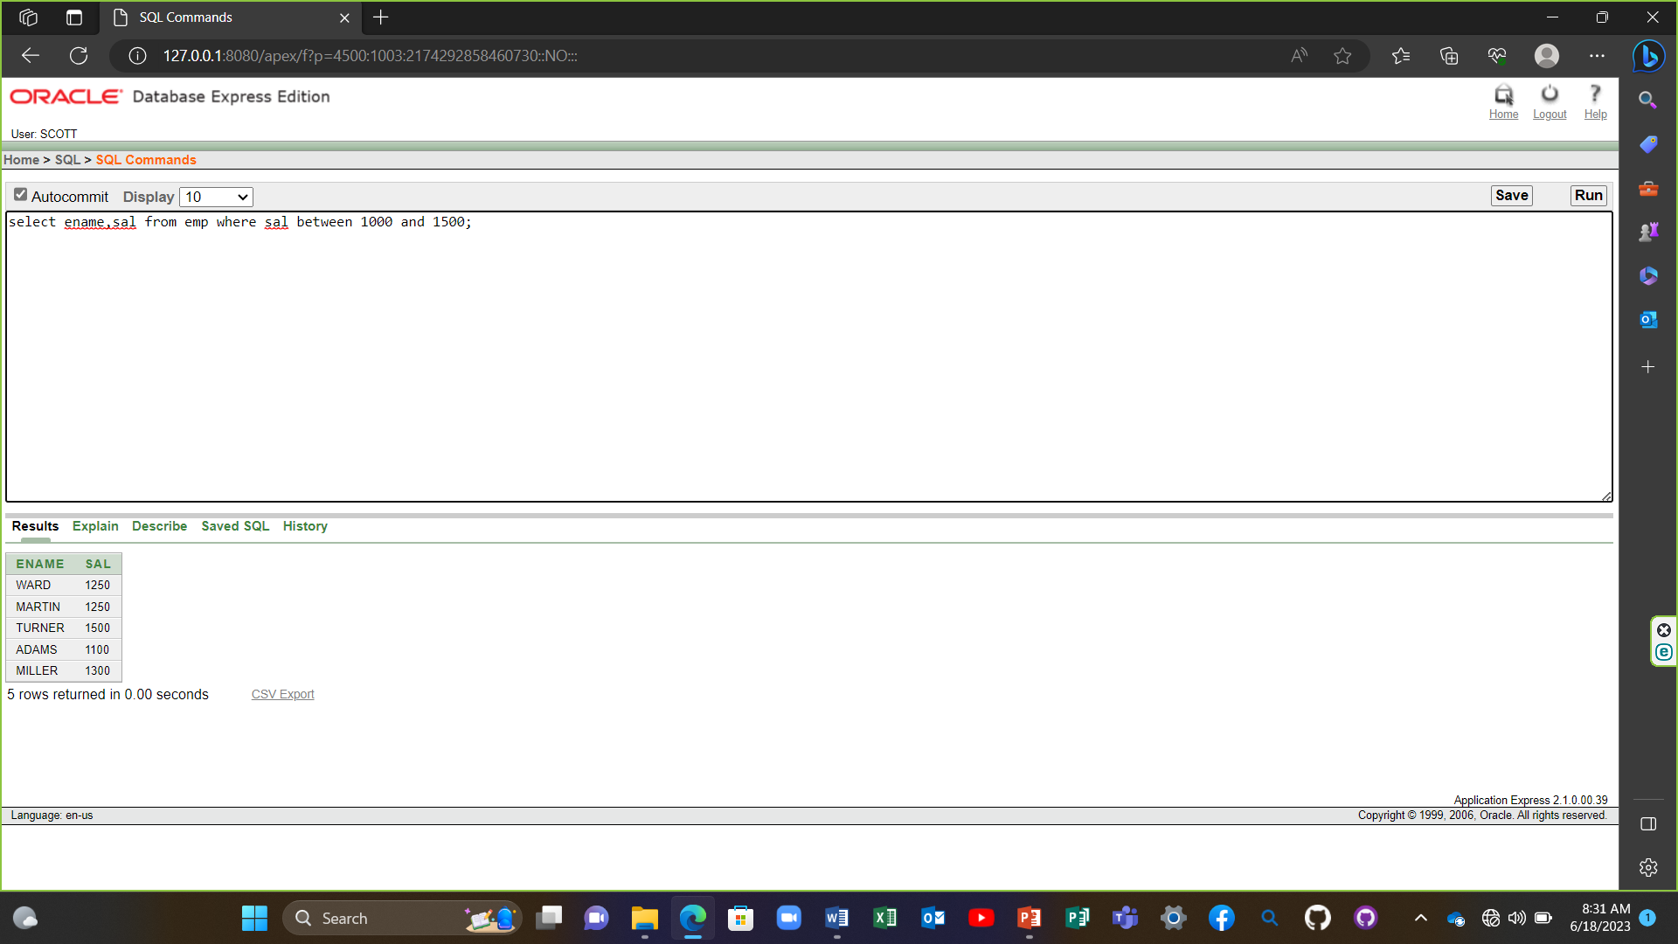

5) select empno,ename,sal,mgr from emp where mgr in (7902,7566,7788);

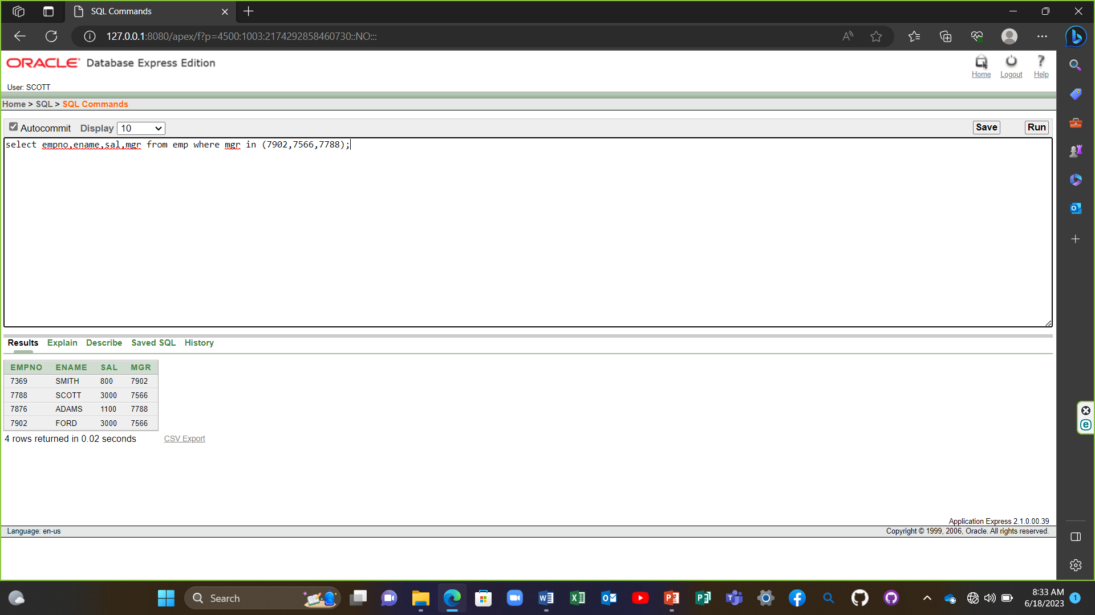

6) select ename from emp where ename like '_A%';

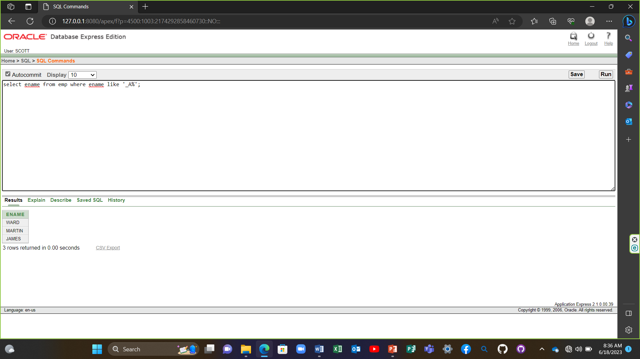

7) select ename,mgr from emp where mgr is null;

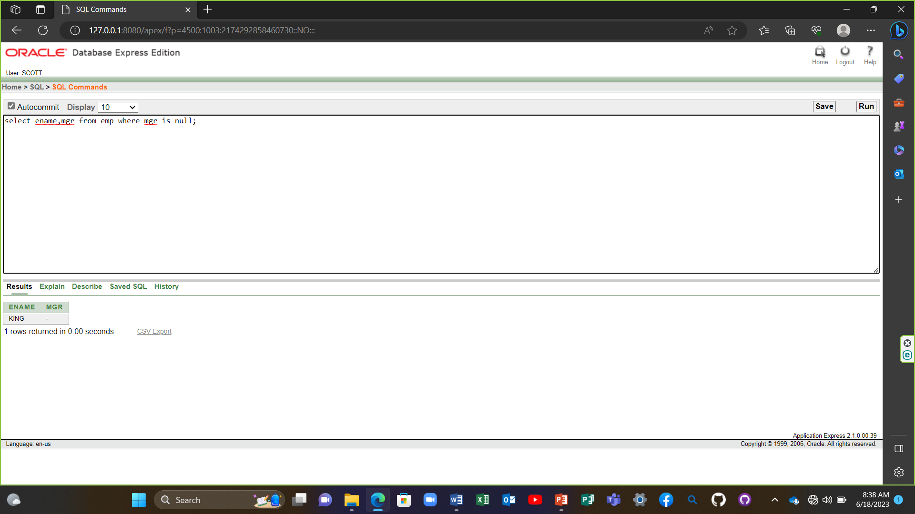

8) select empno,ename,job,sal from emp where sal>=1100 and job='CLERK';

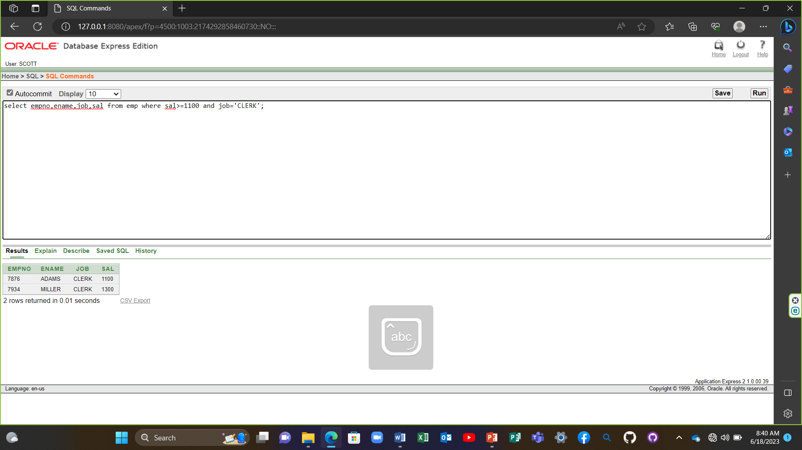

9) select empno,ename,job,sal from emp where sal>=1100 or job='CLERK';

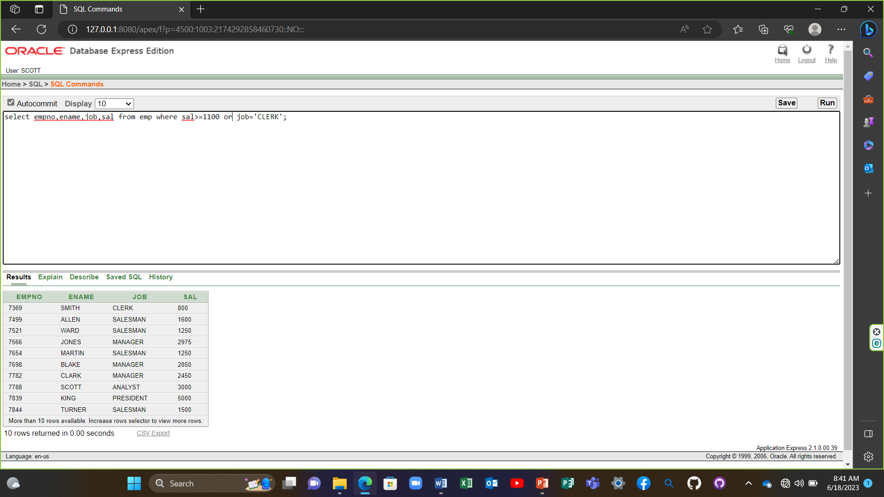

10) select ename,job from emp where job not in ('CLERK','MANAGER','ANALYST');

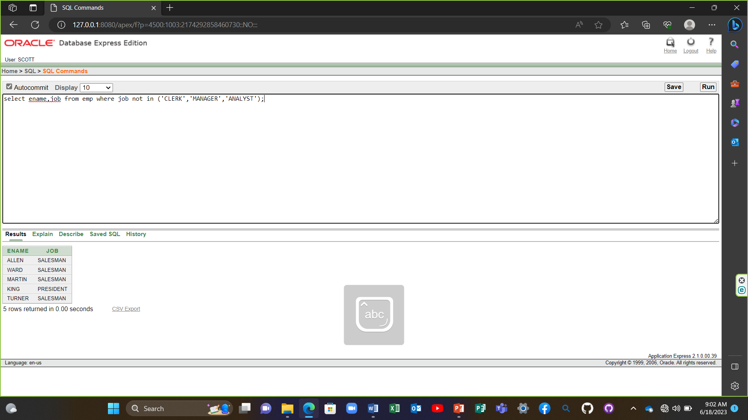

11) select ename,job,sal from emp where (job='SALESMAN' or job ='PRESIDENT') and sal>1500;

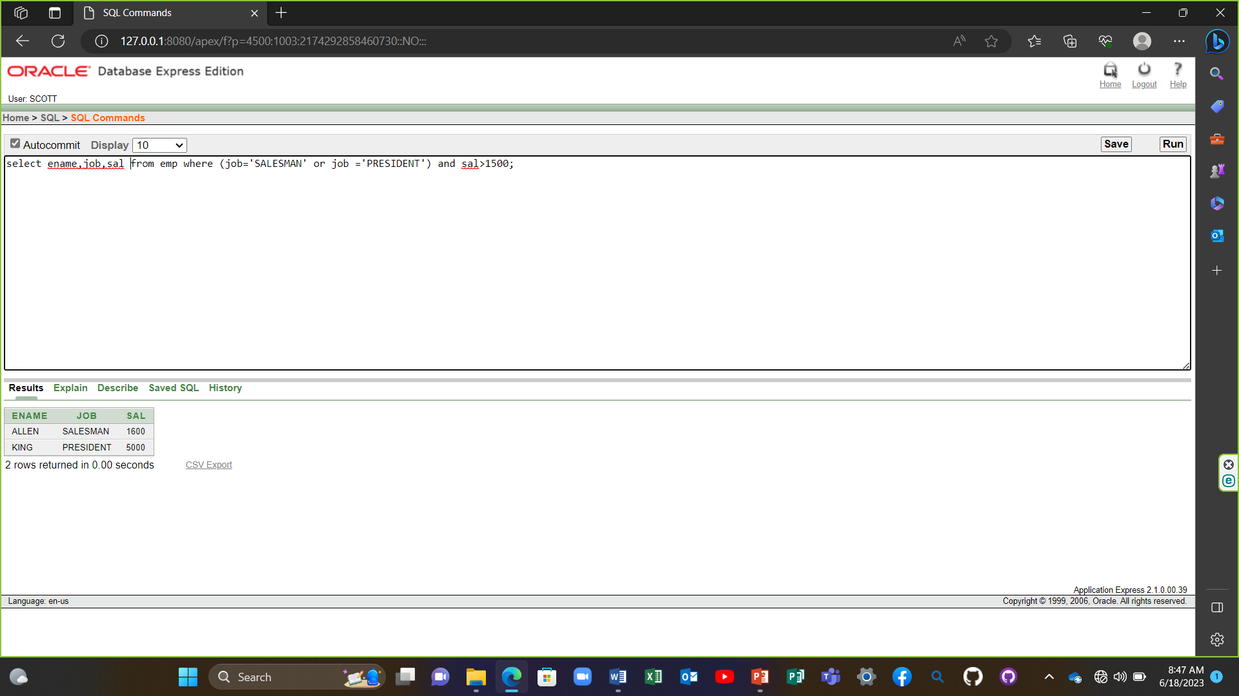

12) select ename,job,sal from emp where job='SALESMAN' or job ='PRESIDENT'and sal>1500;

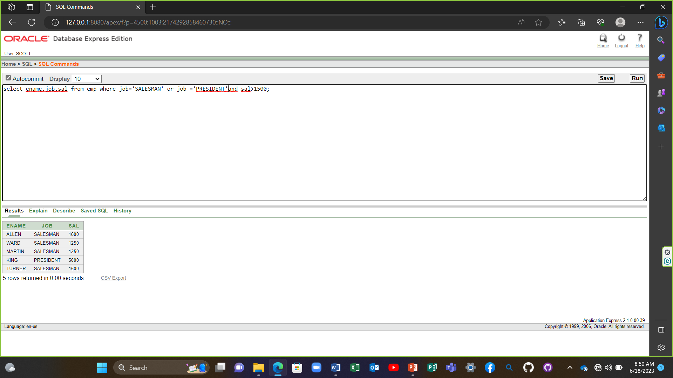

13) select ename,job,deptno,hiredate from emp order by hiredate;

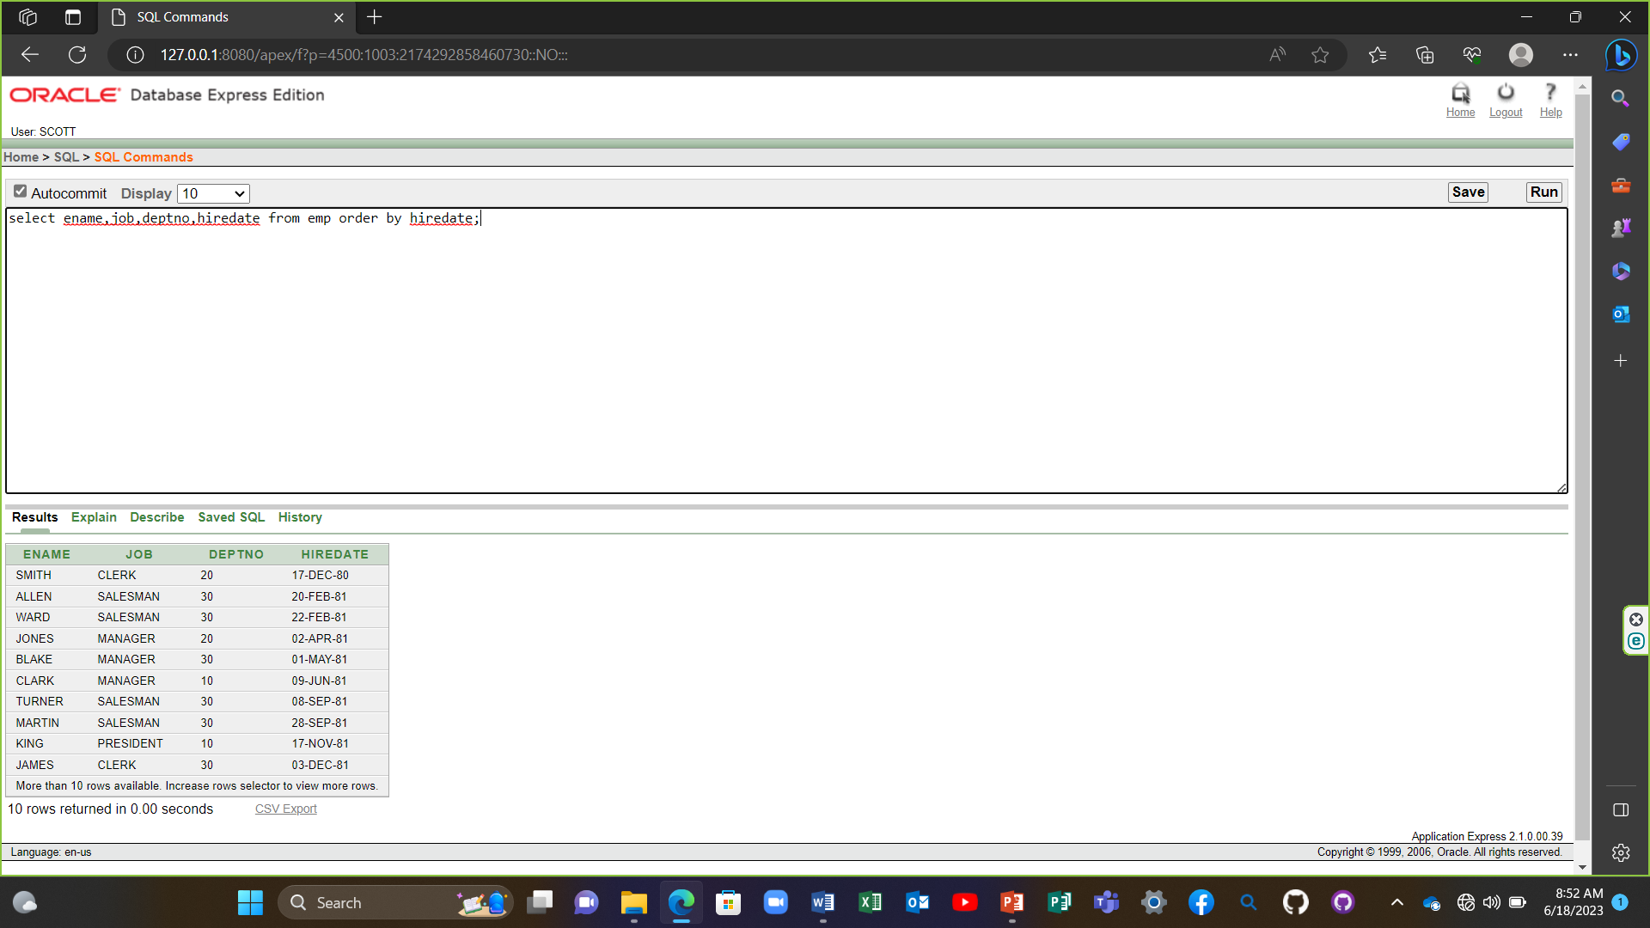

14) select ename,job,deptno,hiredate from emp order by hiredate DESC;

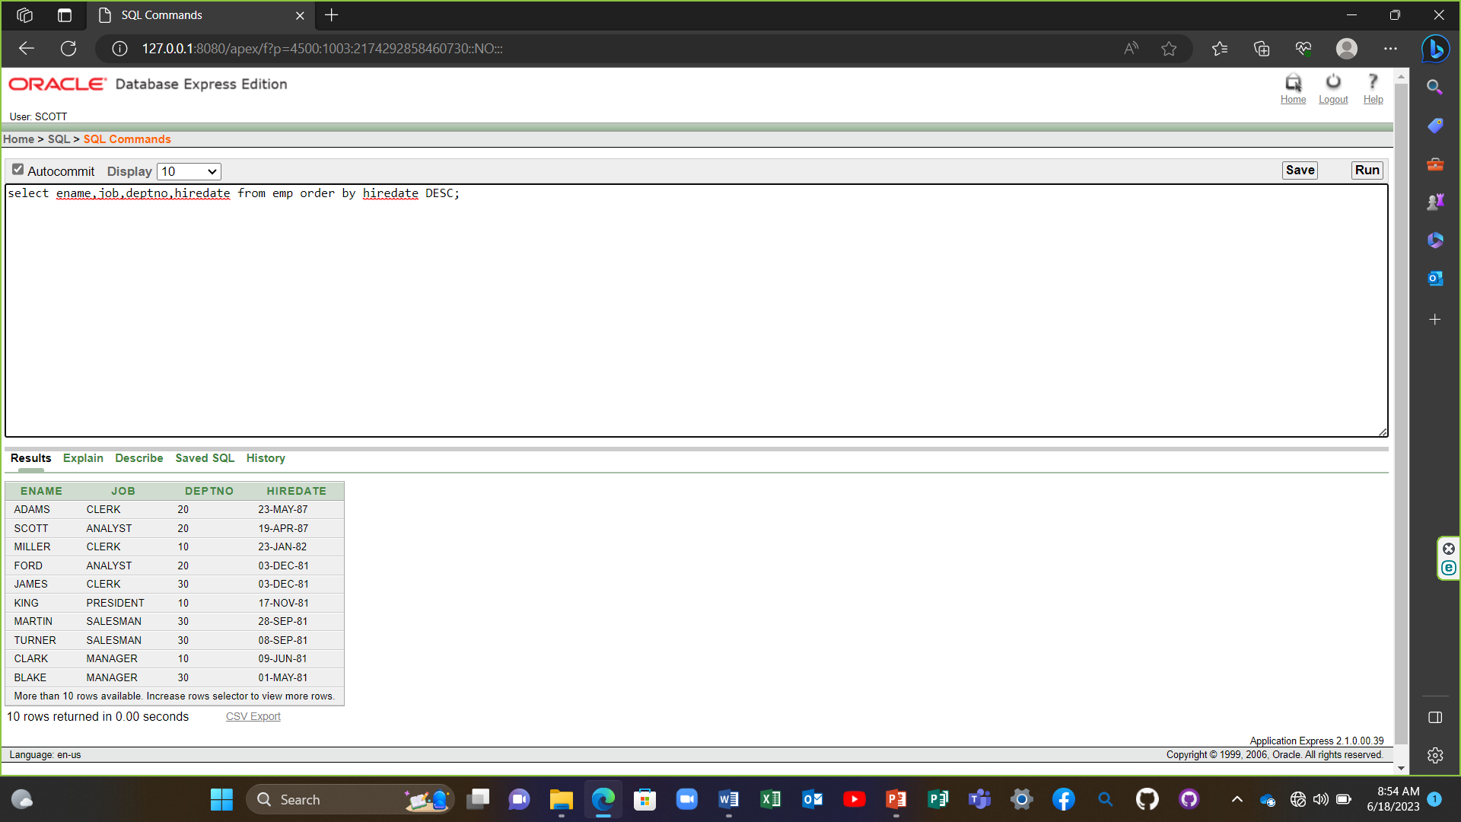

15) select empno,ename,sal*12 annsal from emp order by annsal;

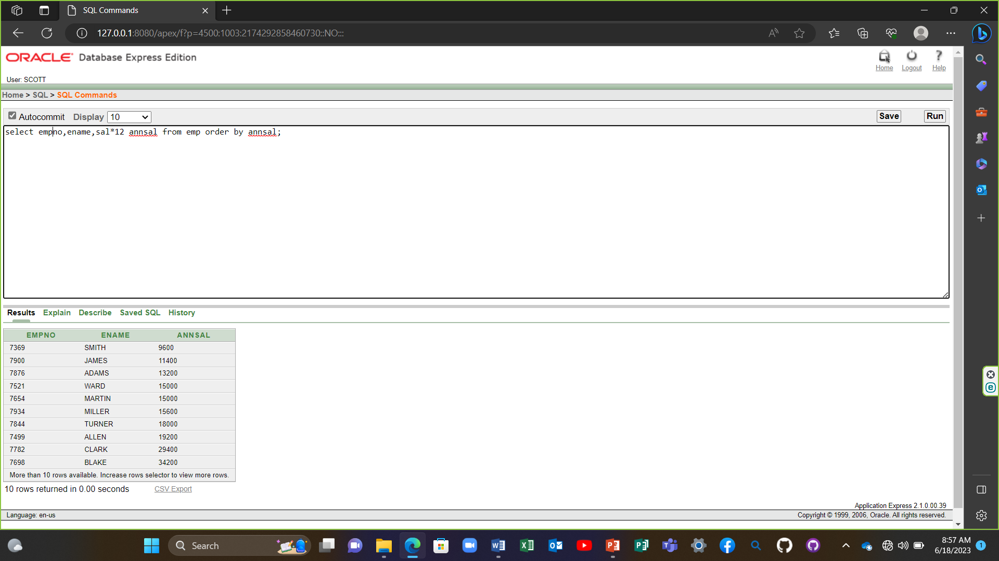

16) select ename,deptno,sal from emp order by deptno,sal DESC;

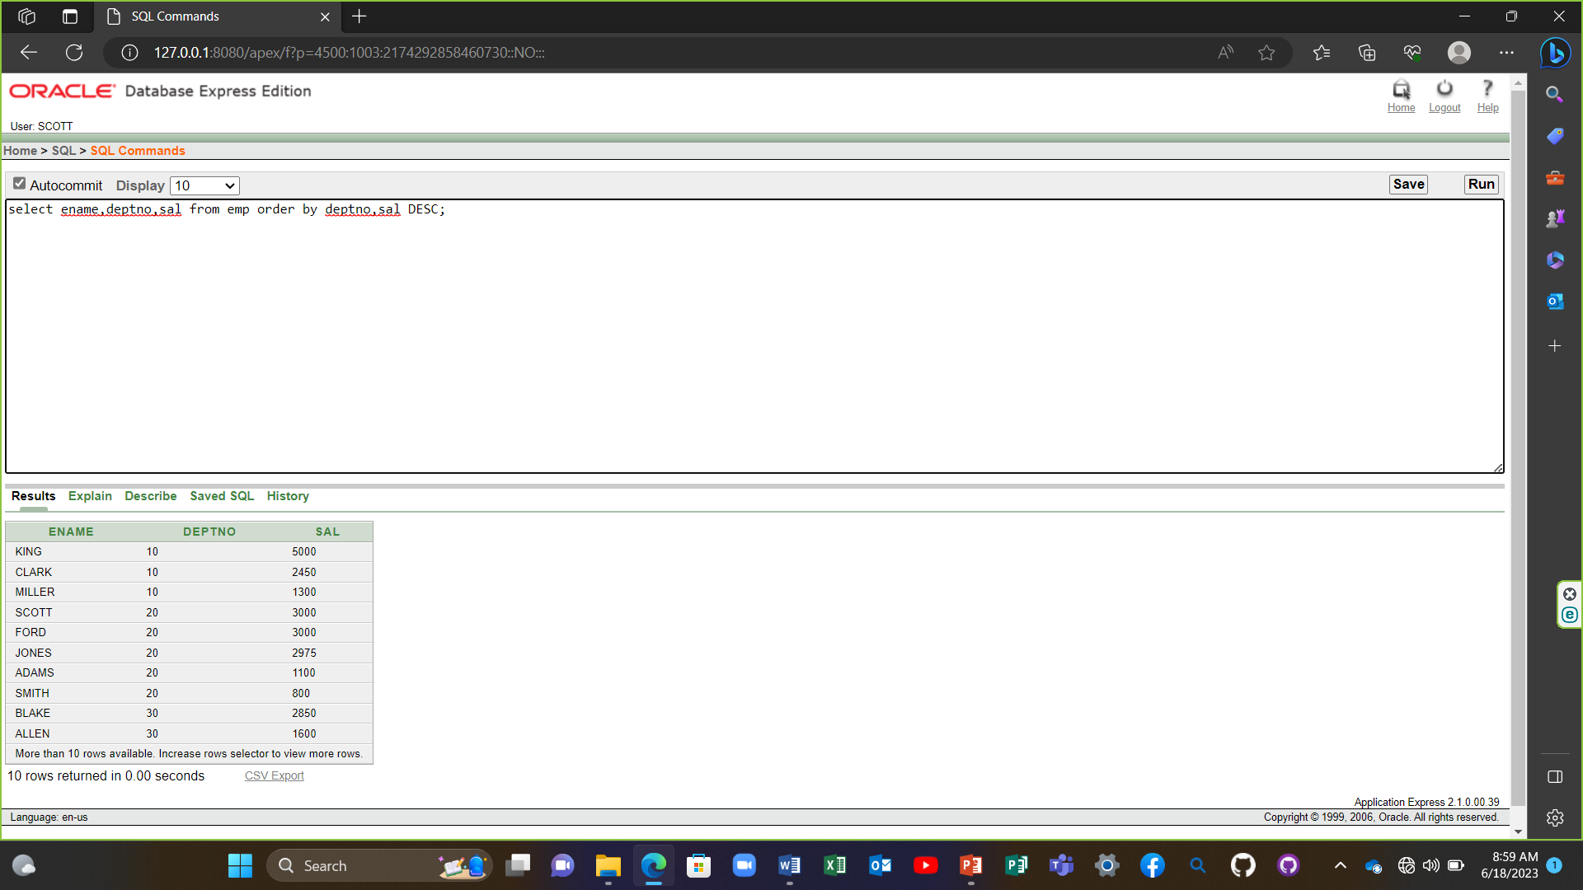

**Lecture 06**

1) select empno,ename,deptno from emp where ename='blake';

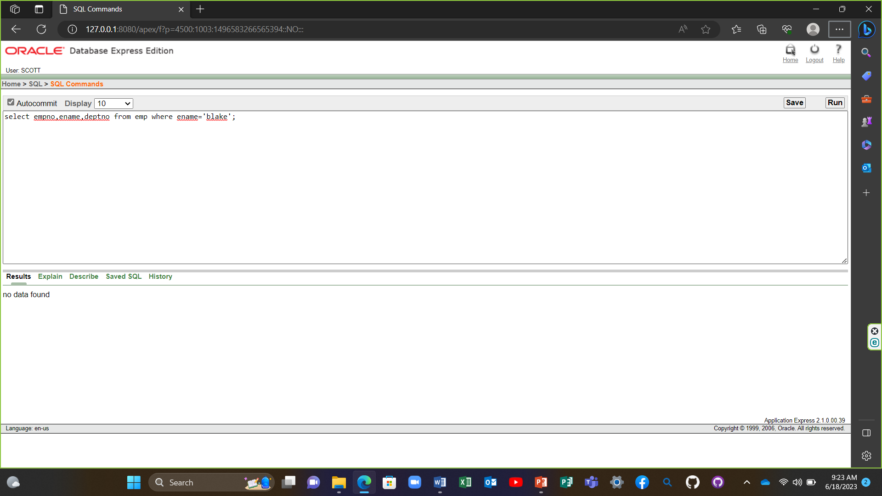

2) select empno,ename,deptno from emp where lower( ename)='blake';

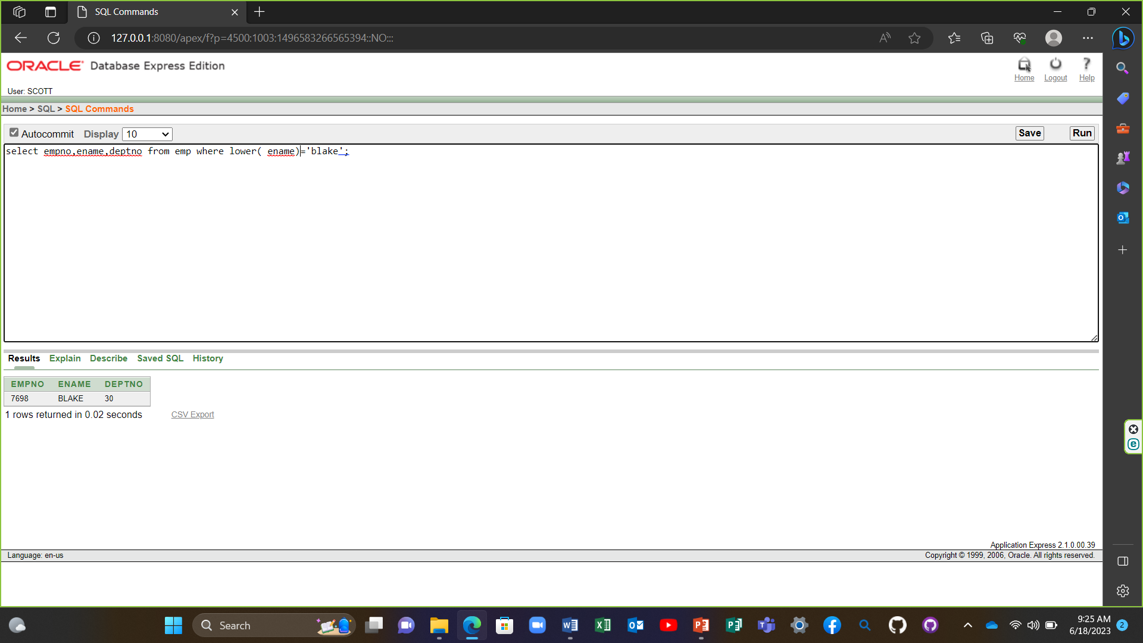

3) SELECT ename, CONCAT (ename, job), LENGTH(ename),INSTR(ename, 'A') FROM emp WHERE SUBSTR(job,1,5) = 'SALES';

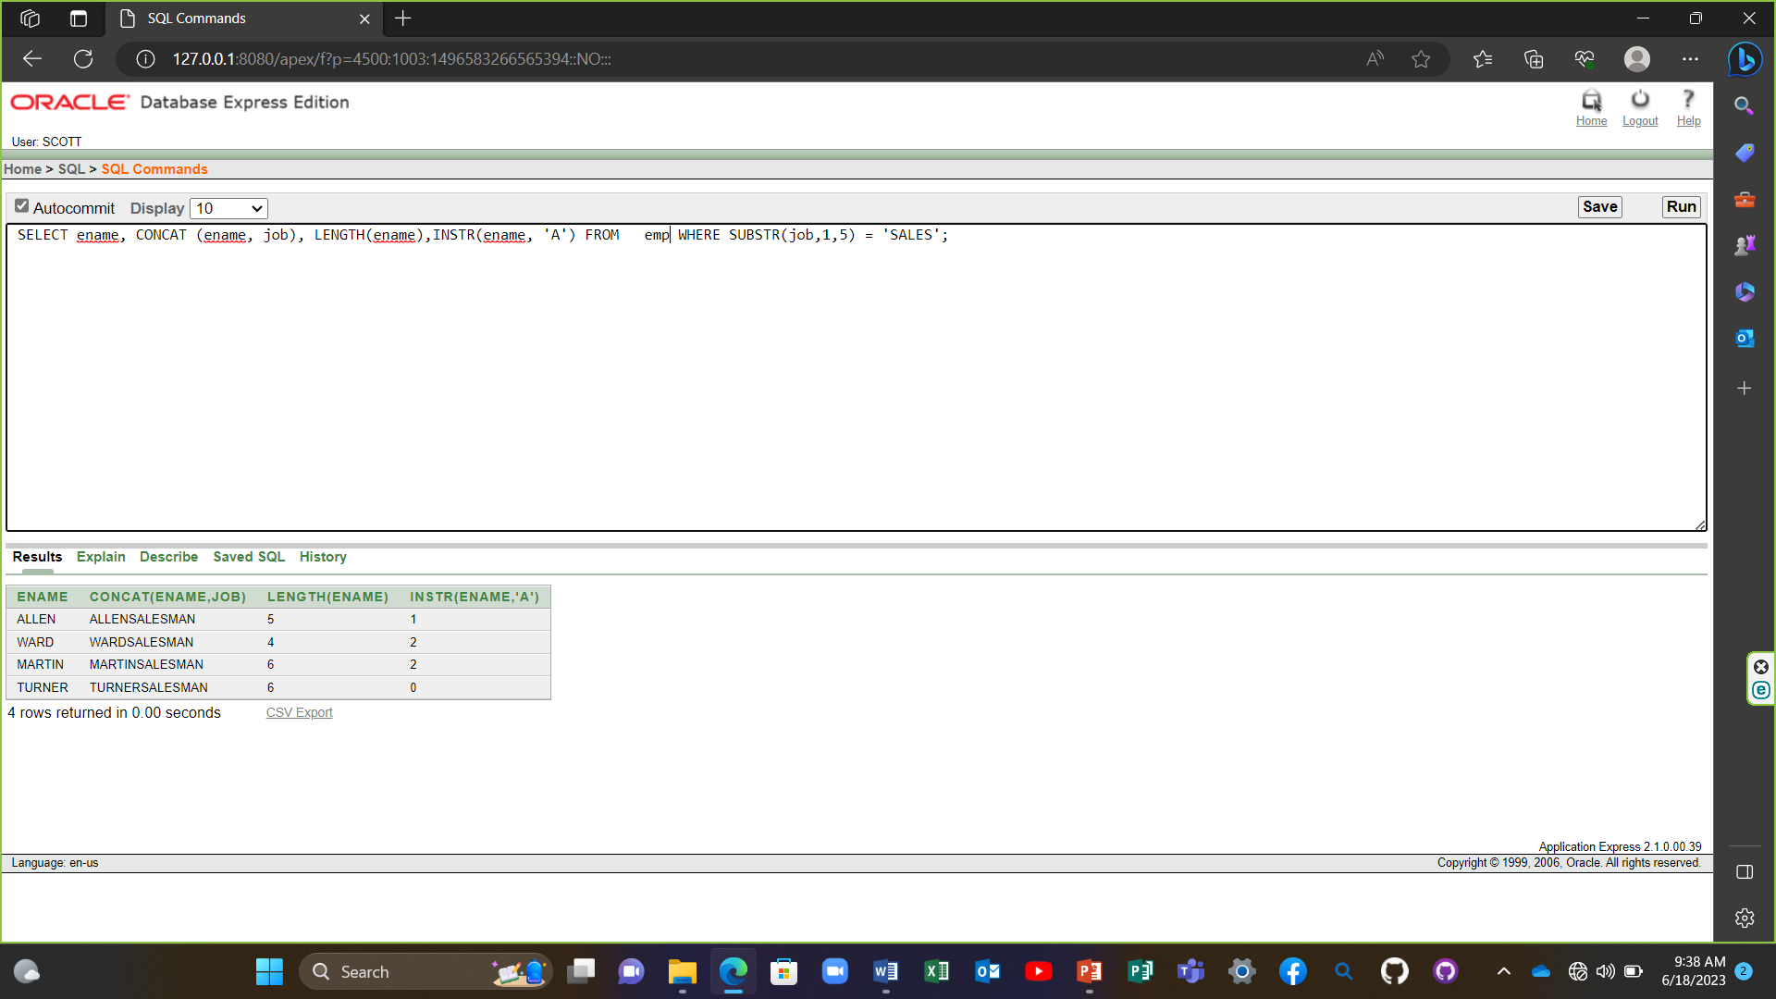

4) SELECT ROUND(45.923,2),ROUND(45.923,0),ROUND(45.923,-1) FROM DUAL;

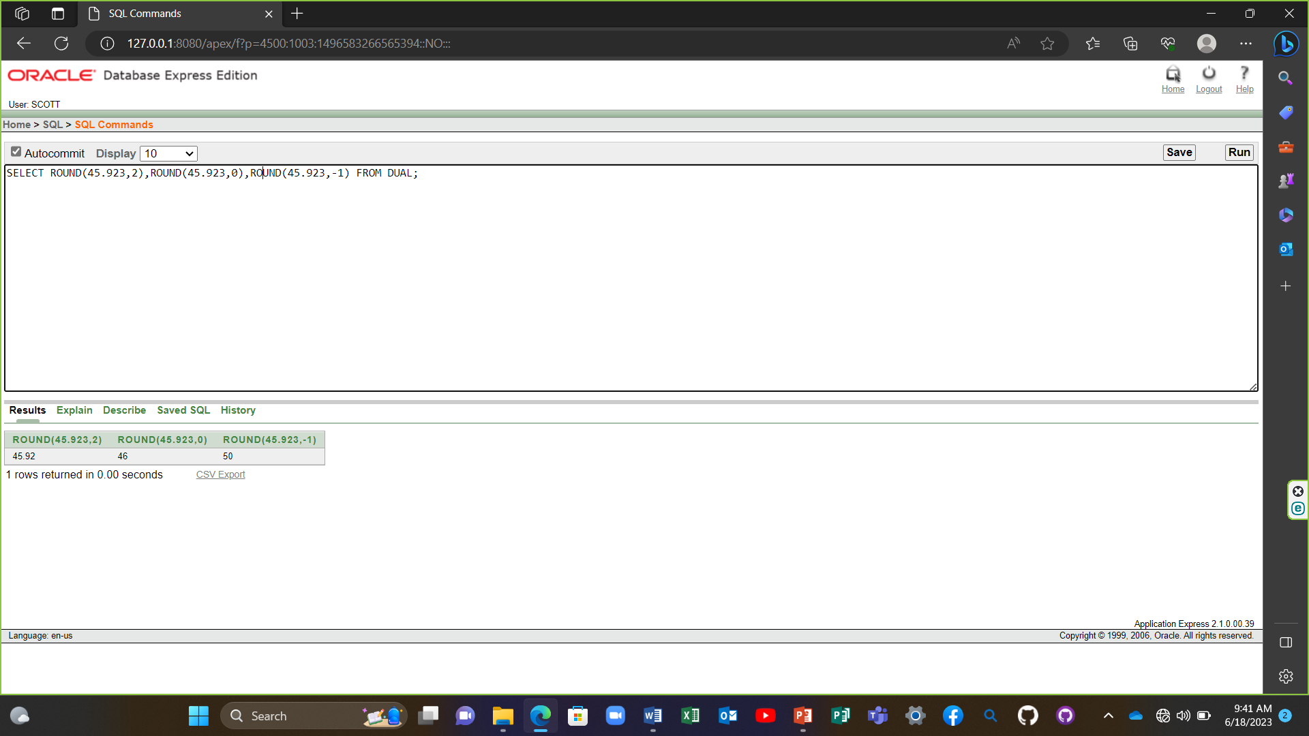

5) SELECT TRUNC(45.923,2),TRUNC(45.923,0),TRUNC(45.923,-1) FROM DUAL; 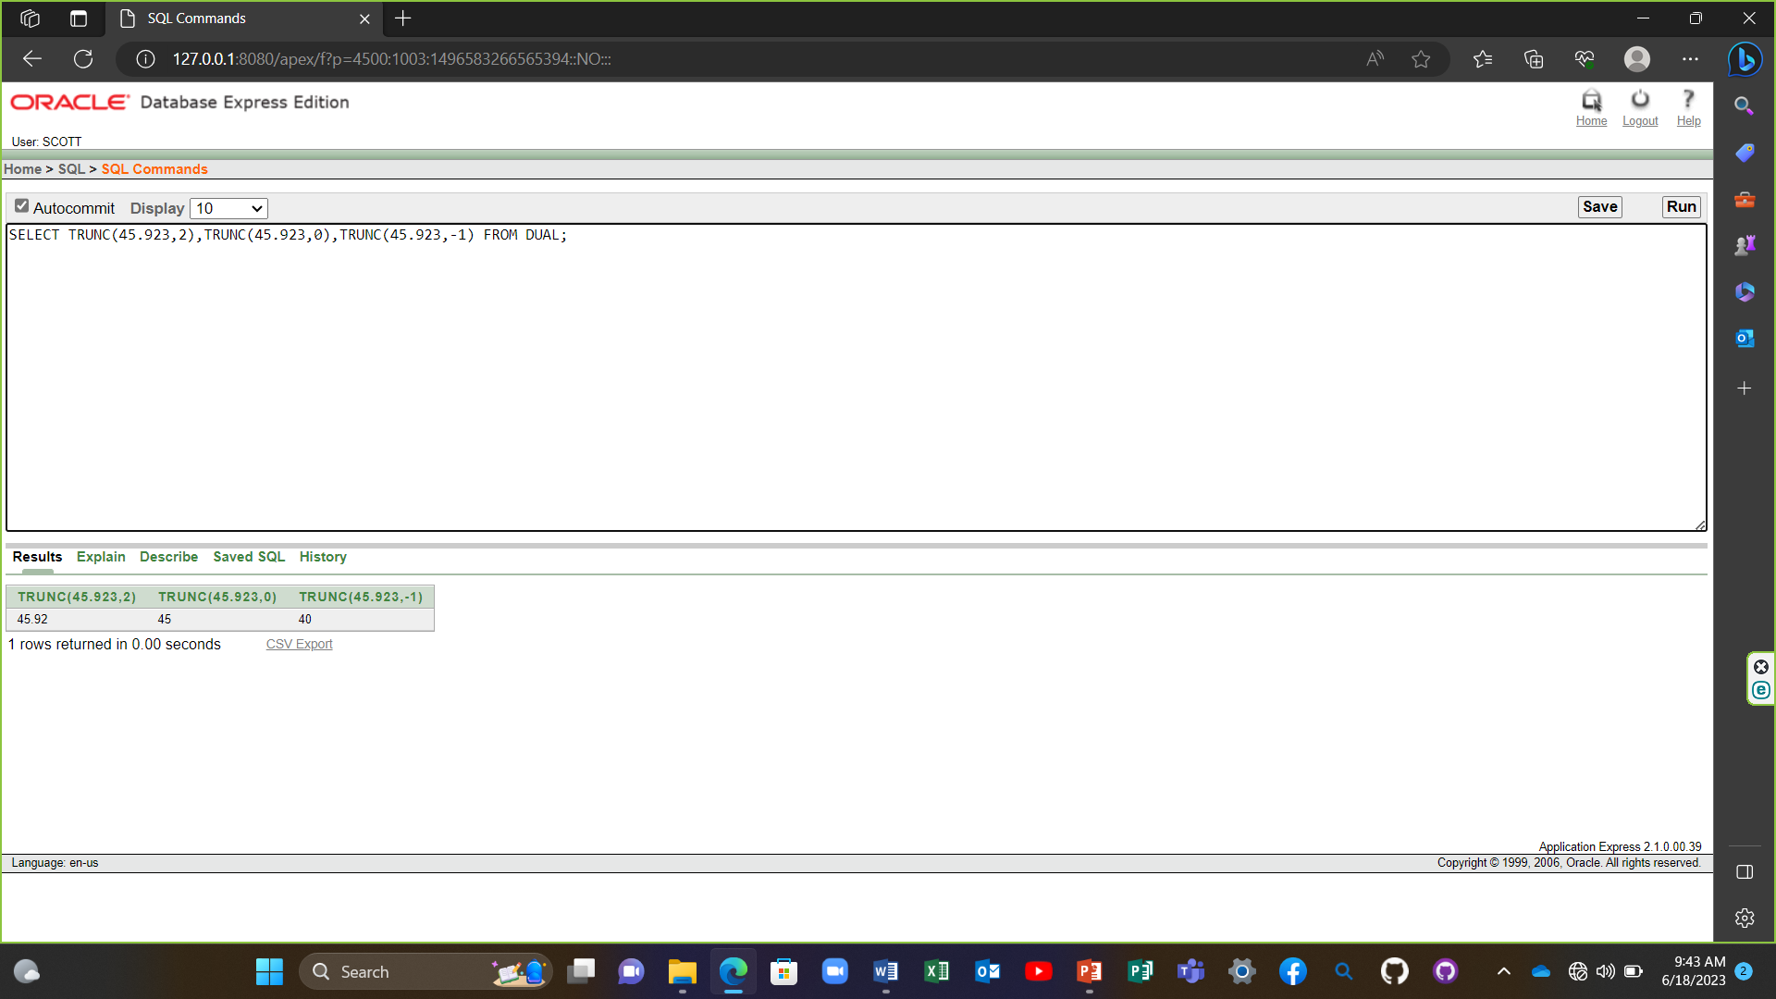

6) SELECT ename, sal, comm, MOD(sal, comm) FROM emp WHERE job = 'SALESMAN';

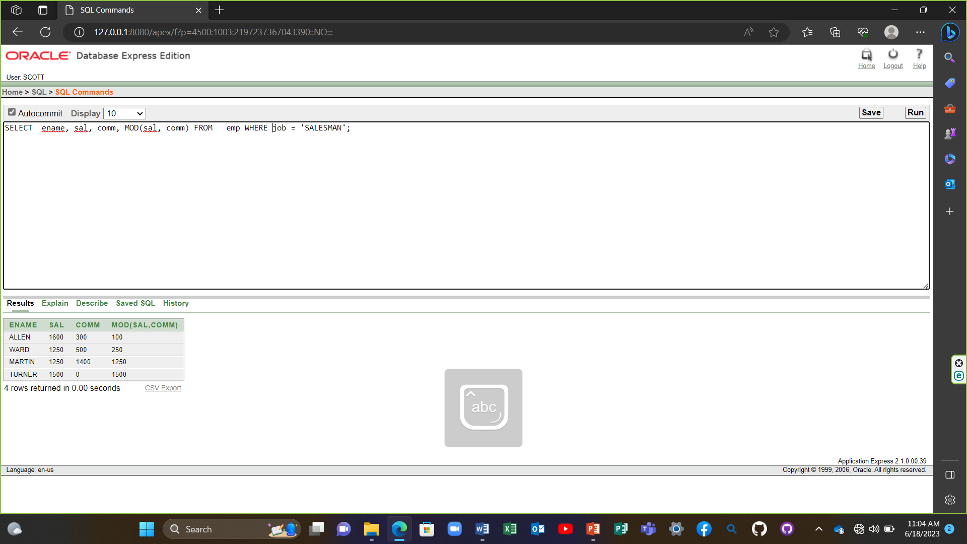

7) SELECT ename, (SYSDATE-hiredate)/7 WEEKS FROM emp WHERE deptno = 10;

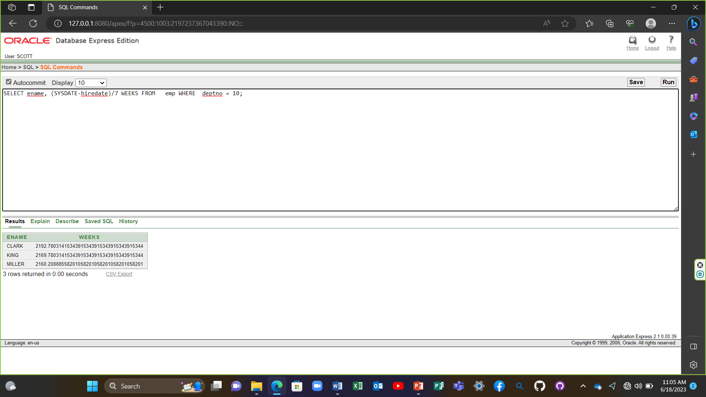

8) SELECT ename,TO_CHAR(hiredate, 'fmDD Month YYYY') HIREDATE FROM emp;

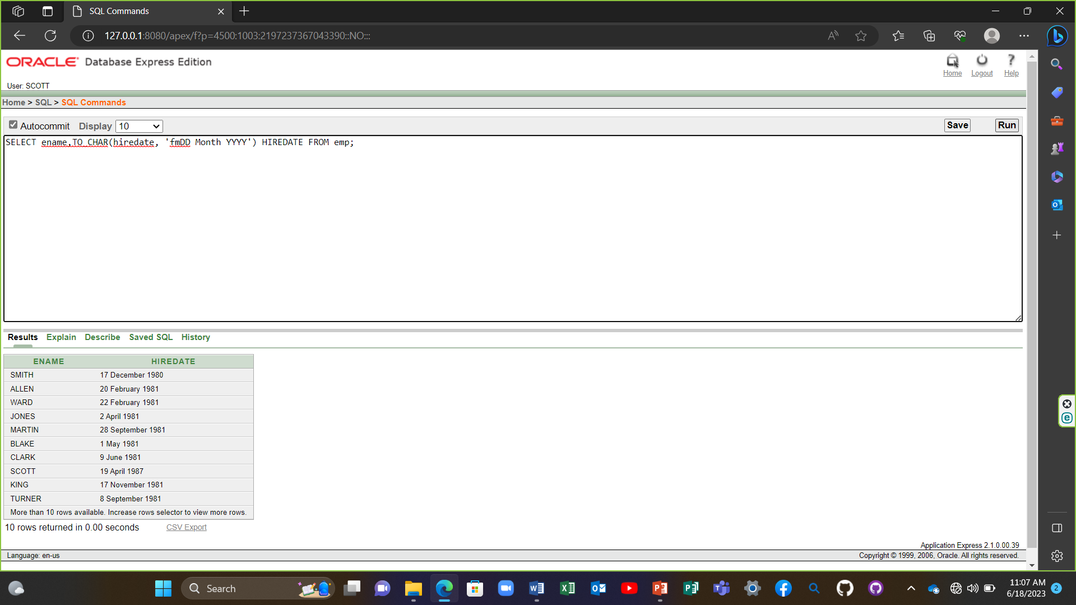

9) SELECT TO_CHAR(sal,'$99,999') SALARY FROM emp WHERE ename = 'SCOTT';

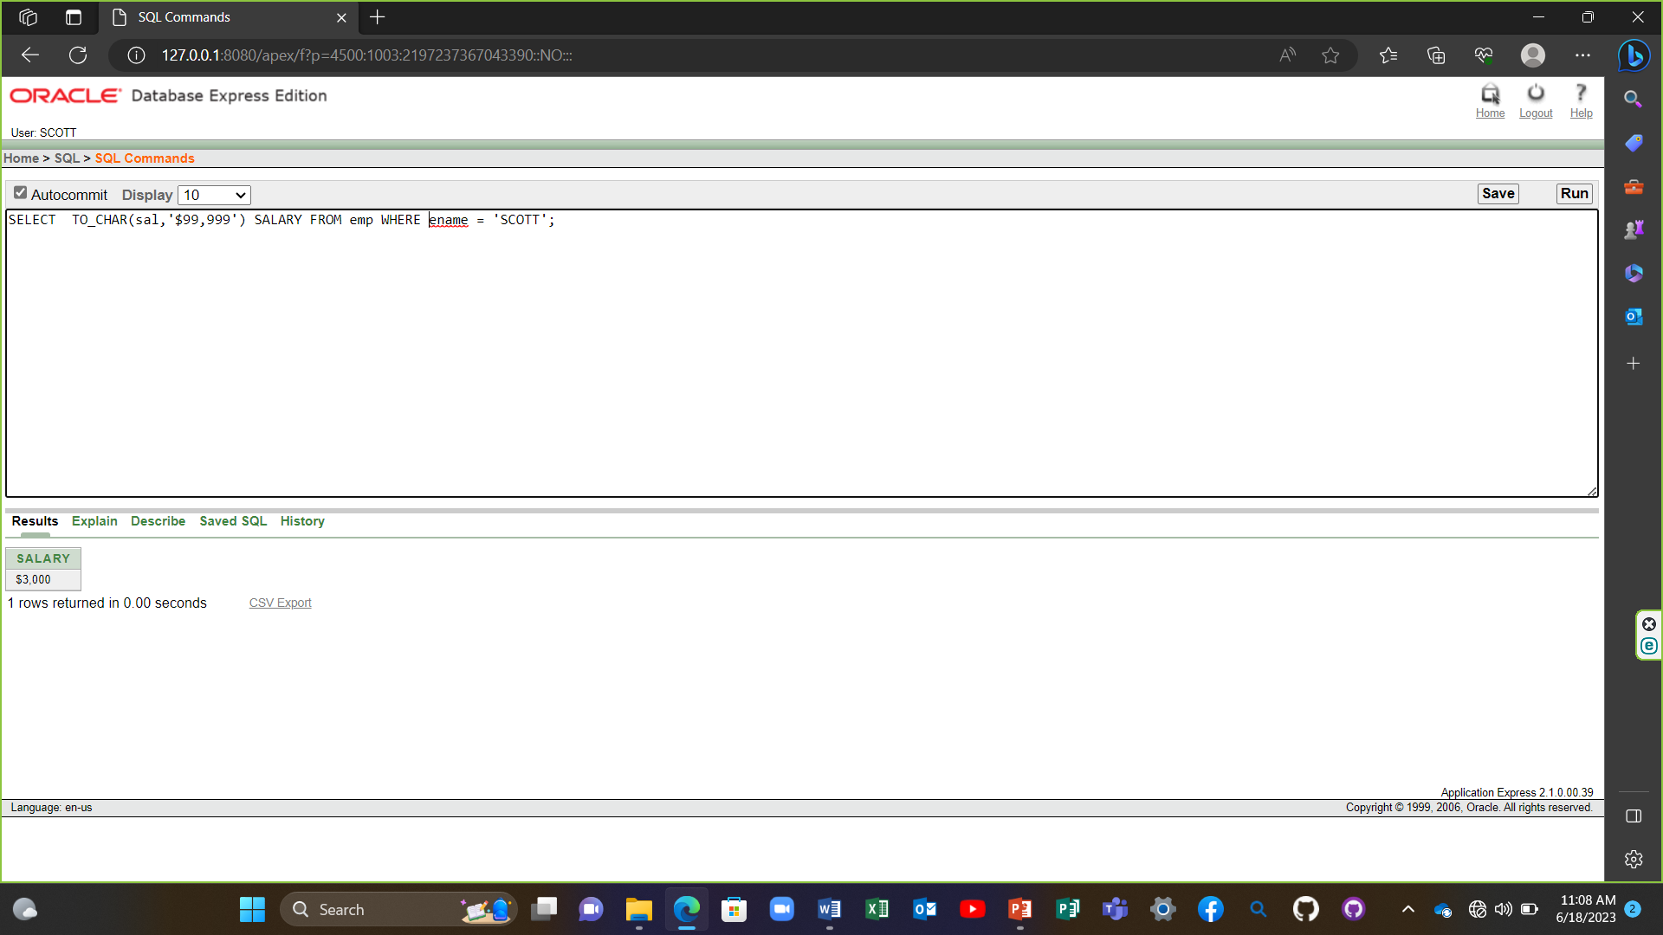

10) SELECT ename, sal, comm, (sal*12)+NVL(comm,0) FROM emp;

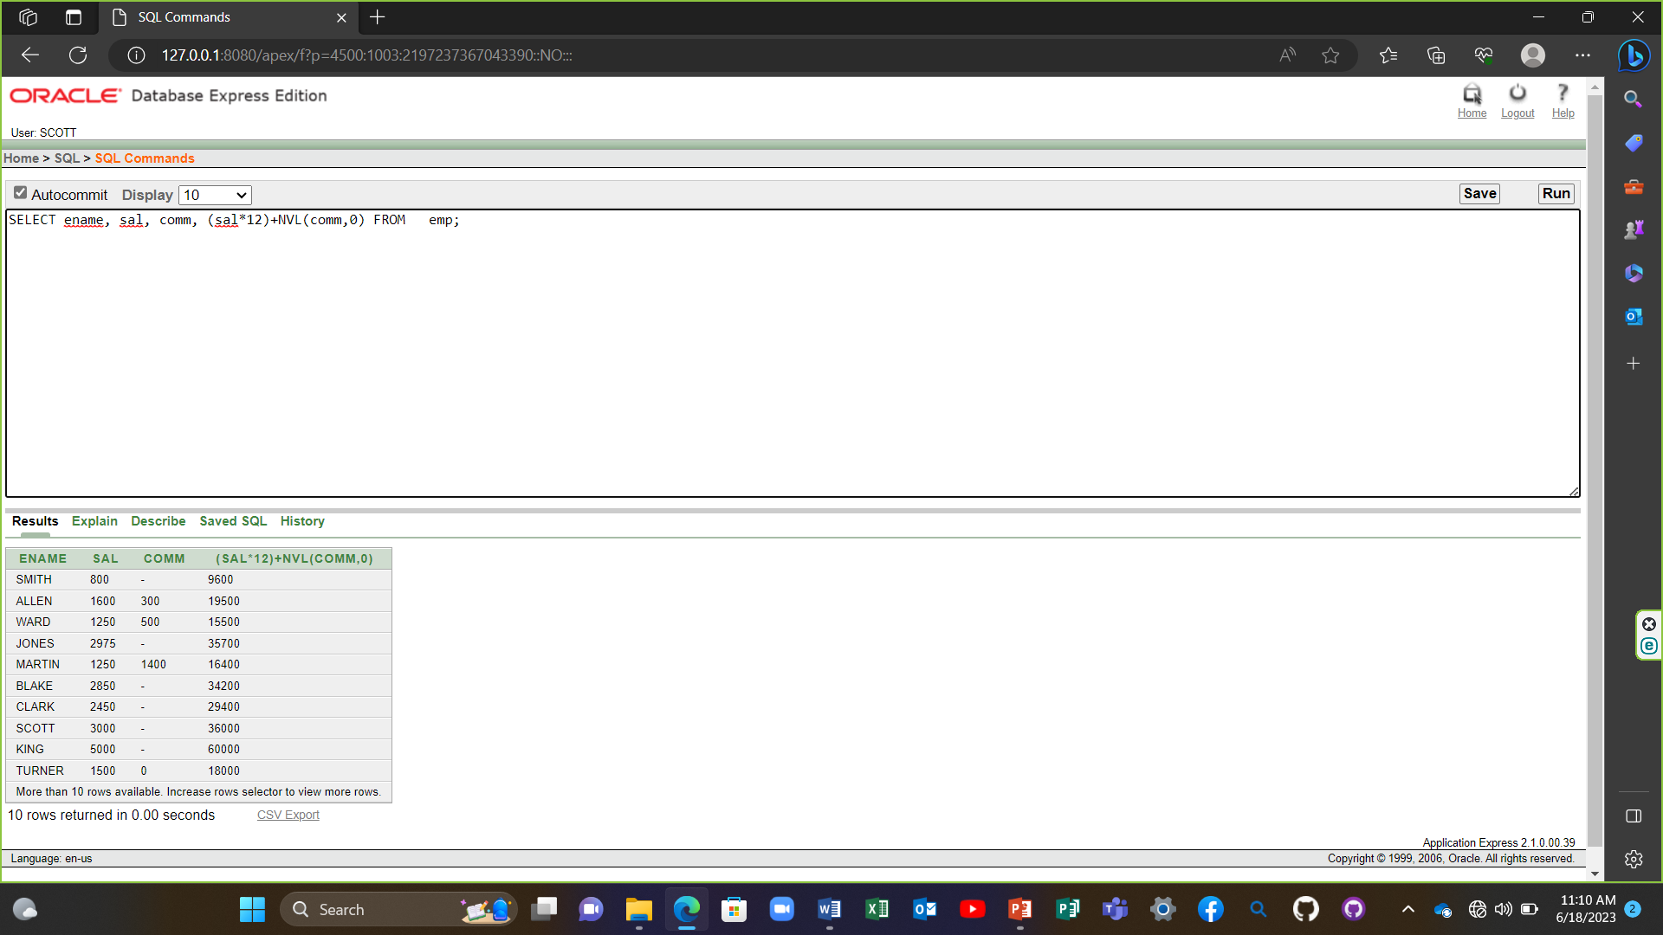

11) SELECT job, sal,DECODE(job, 'ANALYST', SAL*1.1, 'CLERK', SAL*1.15,'MANAGER', SAL*1.20, SAL) REVISED_SALARY FROM emp;

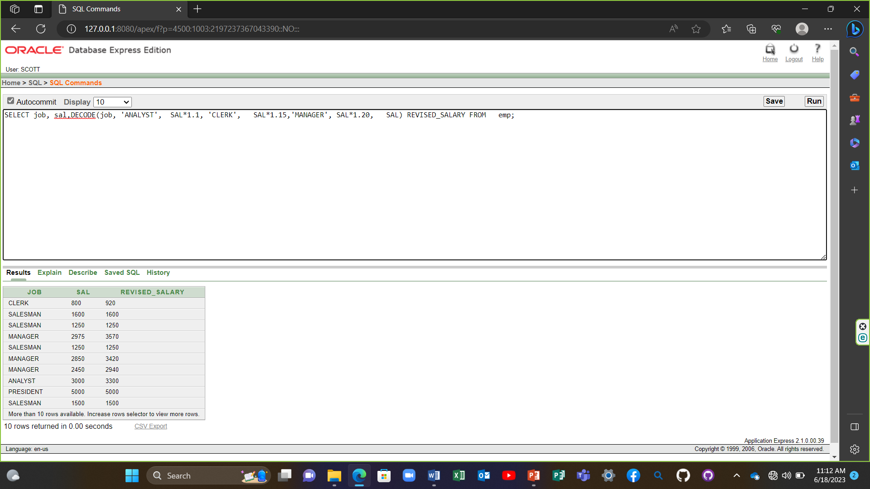

12) SELECT ename,NVL(TO_CHAR(mgr),'No Manager') FROM emp WHERE mgr IS NULL;

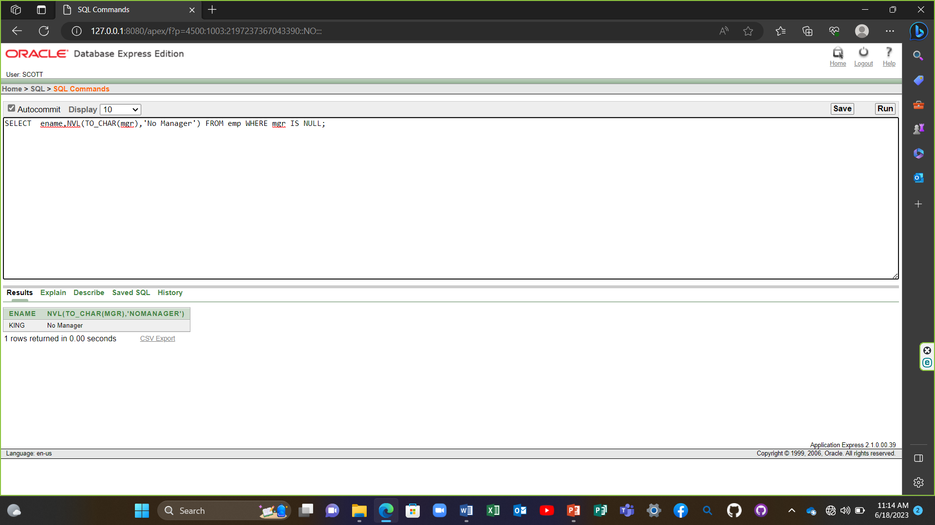

**Lesson -8**

1) SELECT AVG(sal), MAX(sal),MIN(sal), SUM(sal) FROM emp WHERE job LIKE 'SALES%';

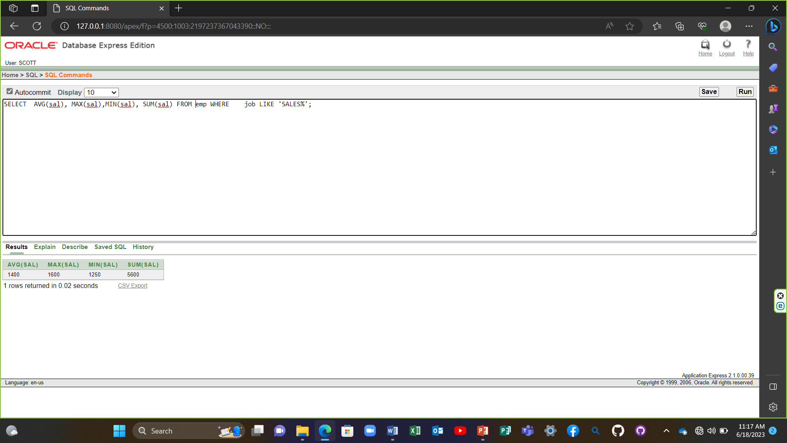

2) SELECT MIN(hiredate), MAX(hiredate) FROM emp;

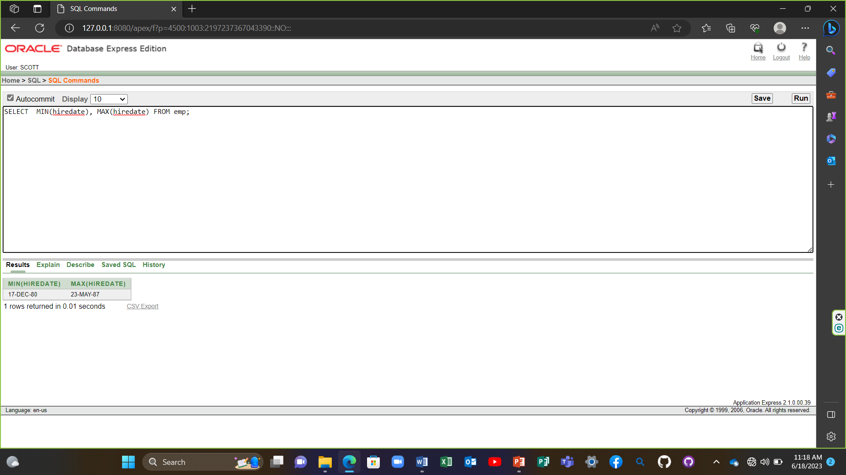

3) SELECT COUNT(*) FROM emp WHERE deptno = 30;

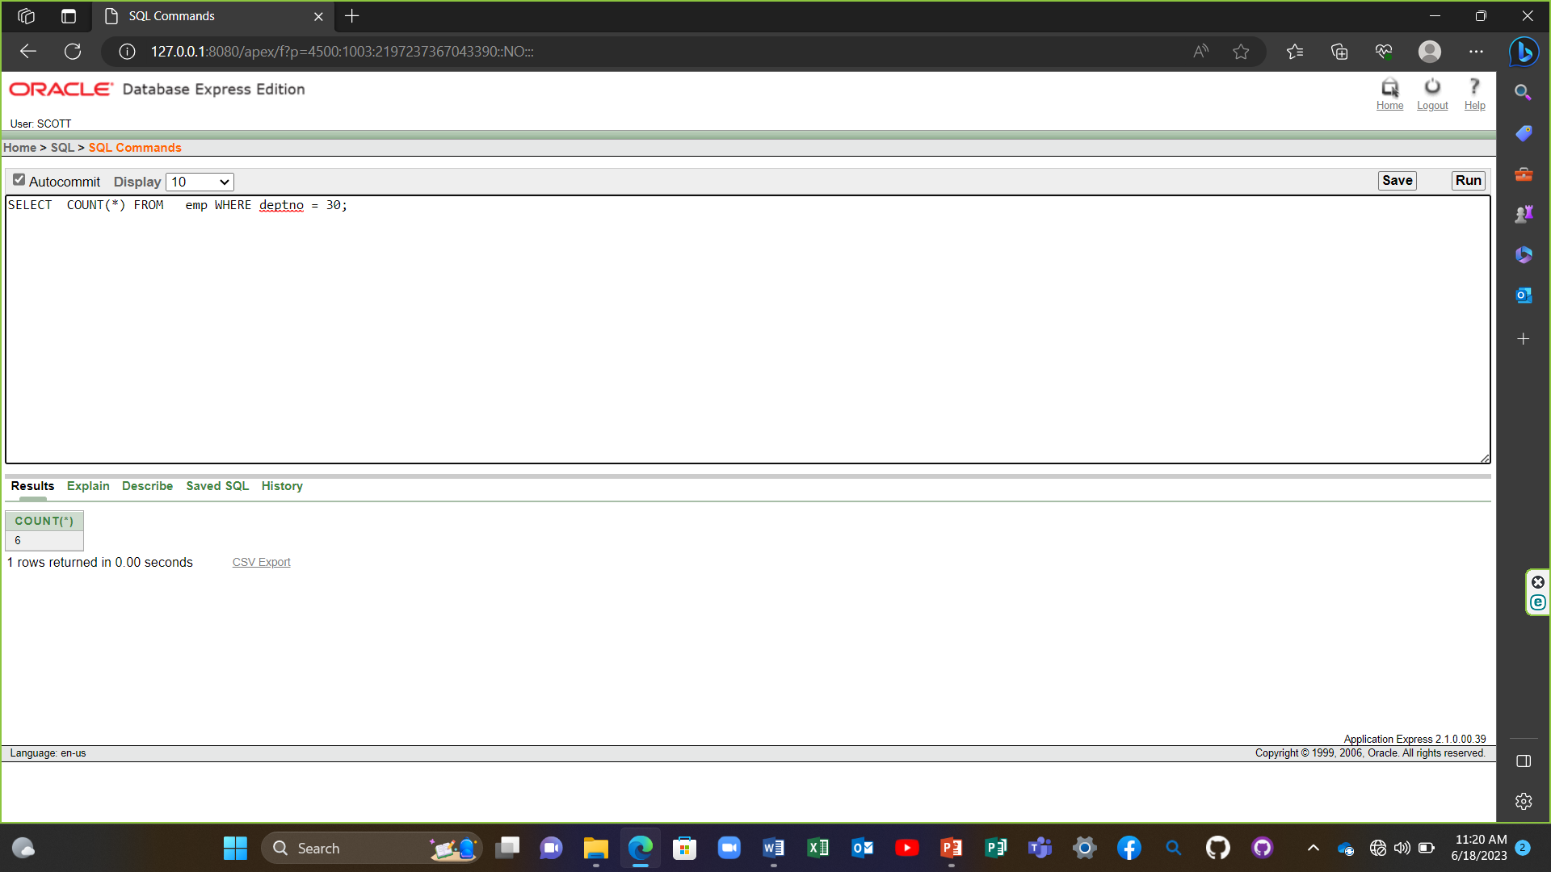

4) SELECT COUNT(comm) FROM emp WHERE deptno = 30;

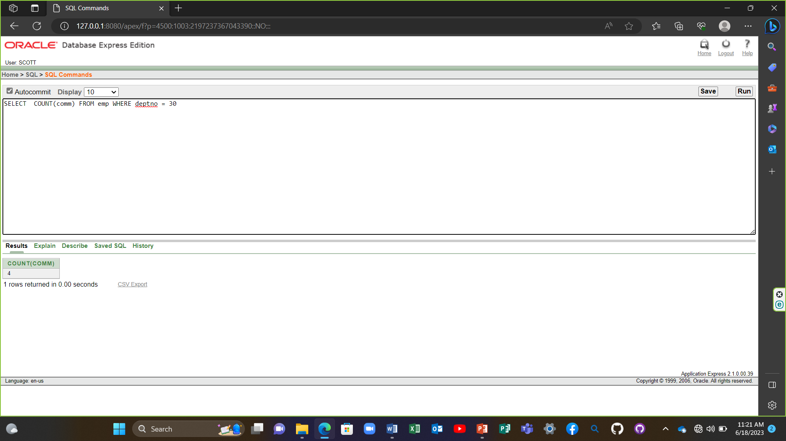

5) SELECT AVG(comm) FROM emp;

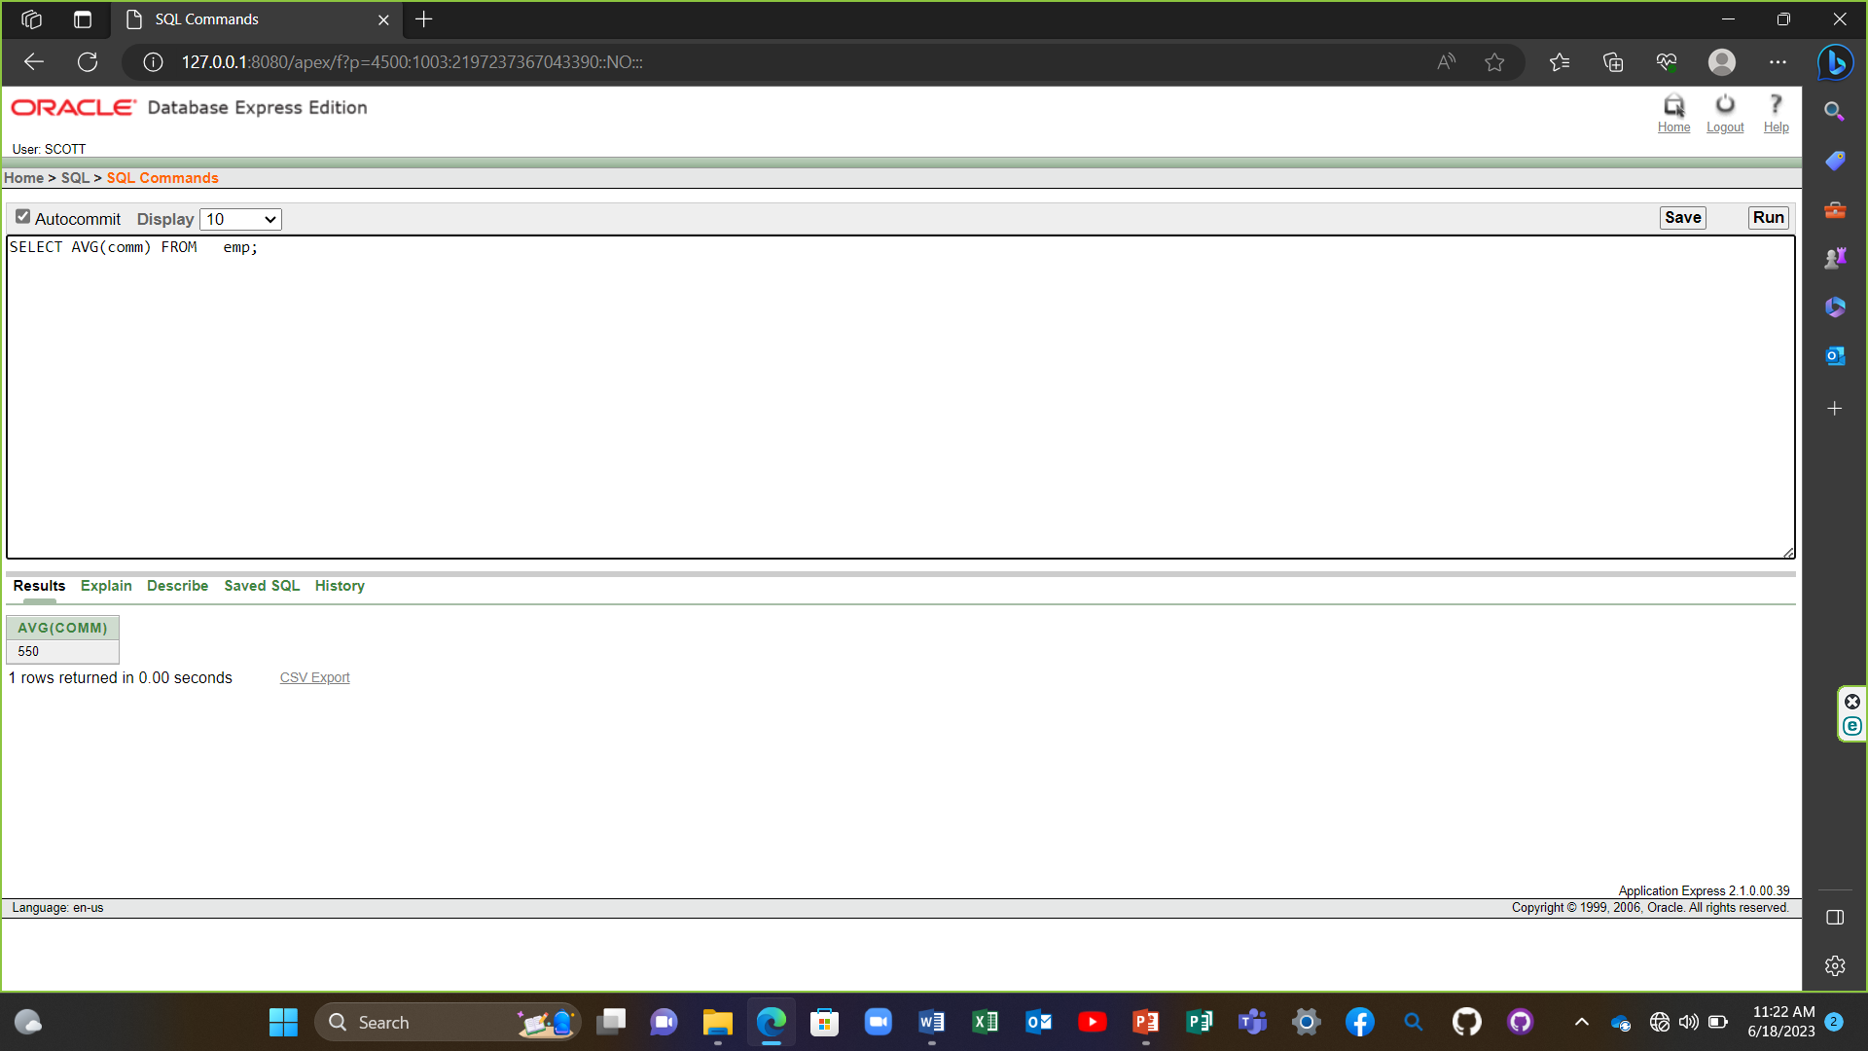

6) SELECT AVG(NVL(comm,0)) FROM emp;

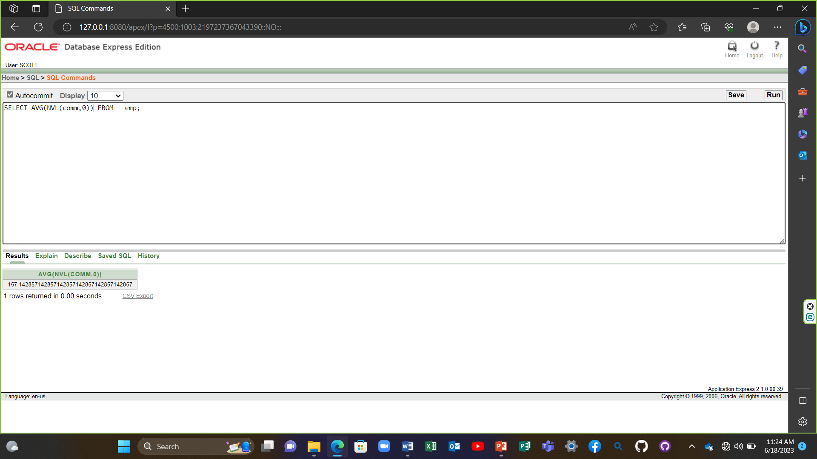

7) SELECT deptno, AVG(sal) FROM emp GROUP BY deptno;

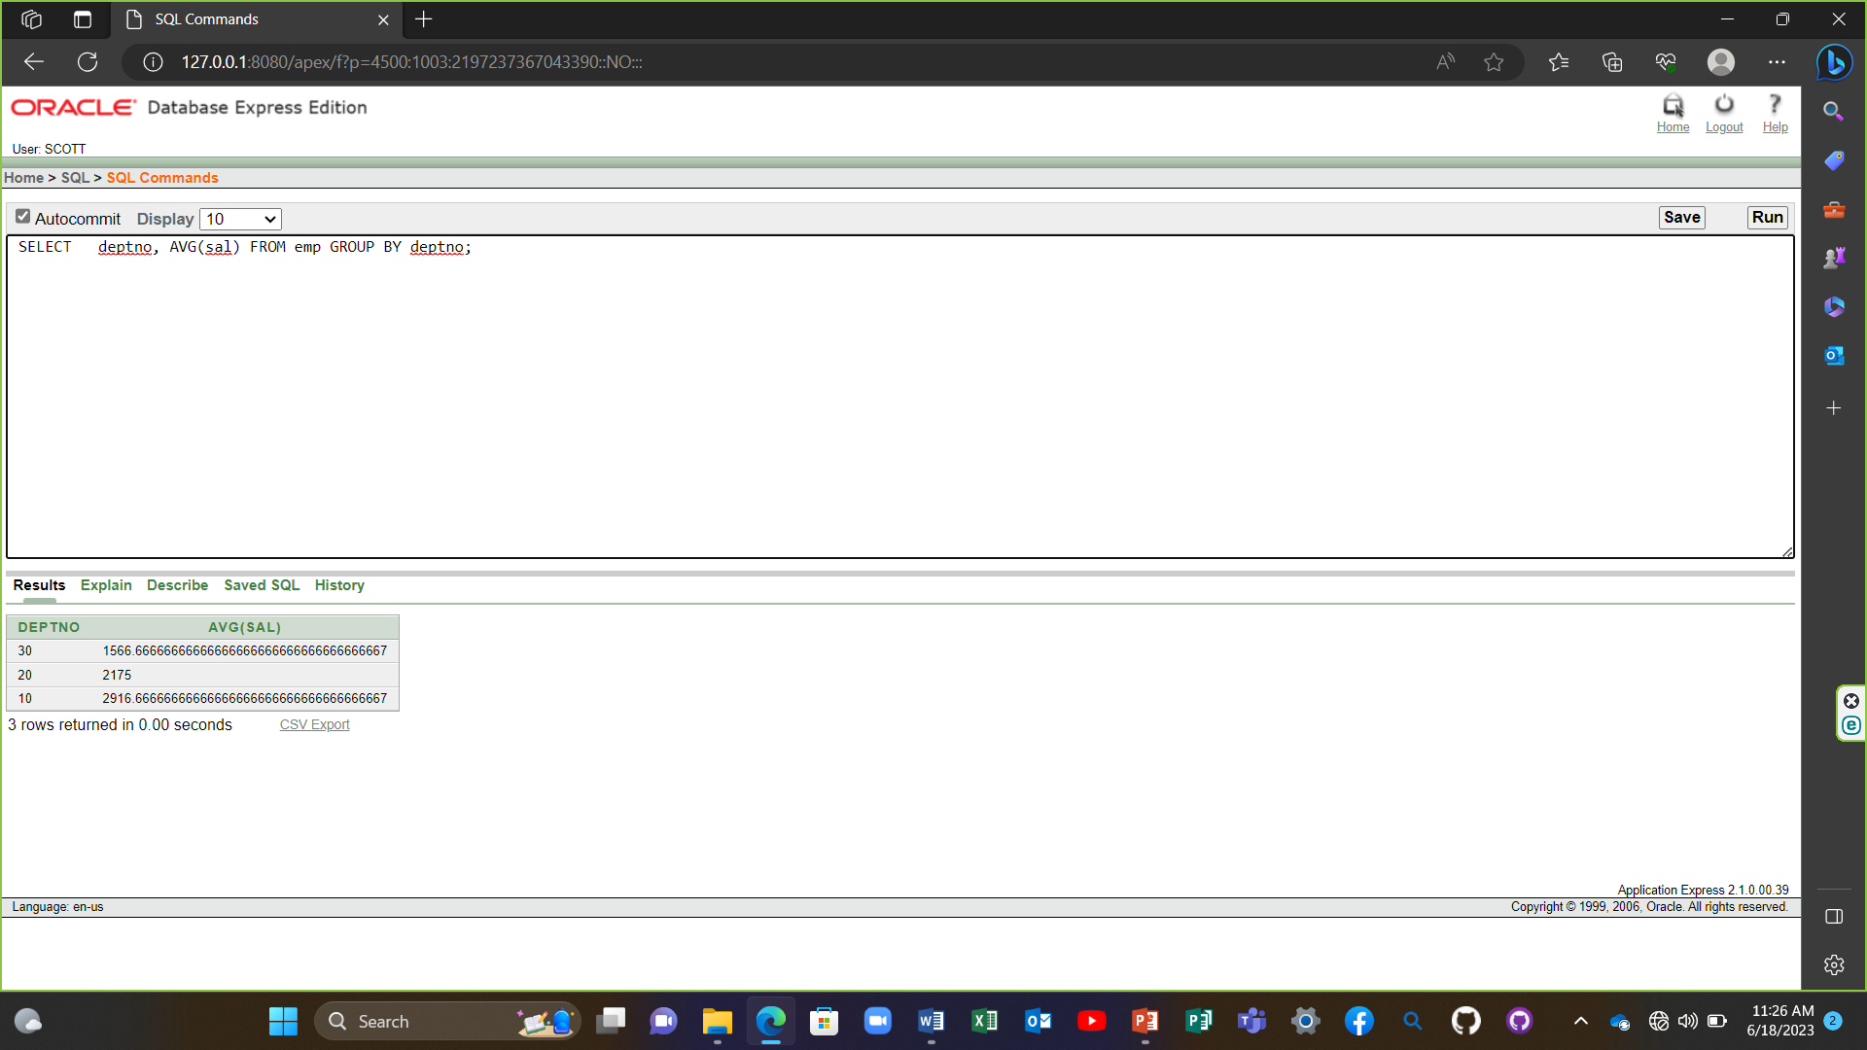

8) SELECT AVG(sal) FROM emp GROUP BY deptno;

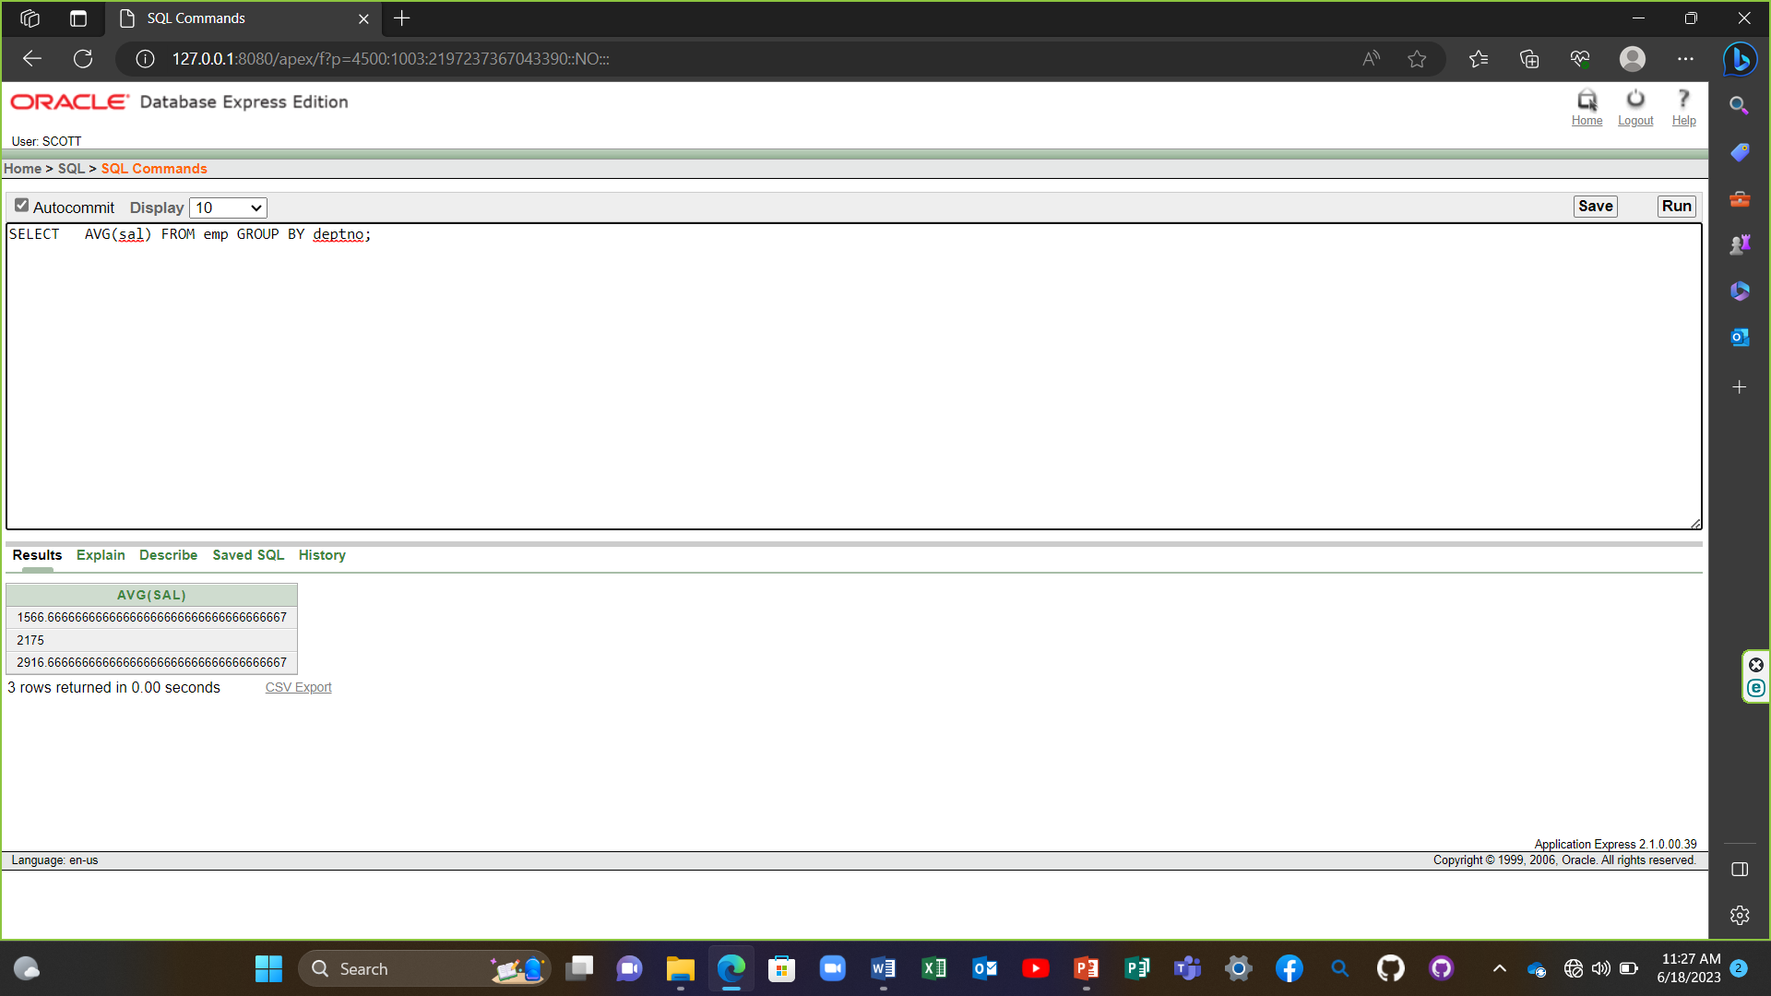

9) SELECT deptno, job, sum(sal) FROM emp GROUP BY deptno, job;

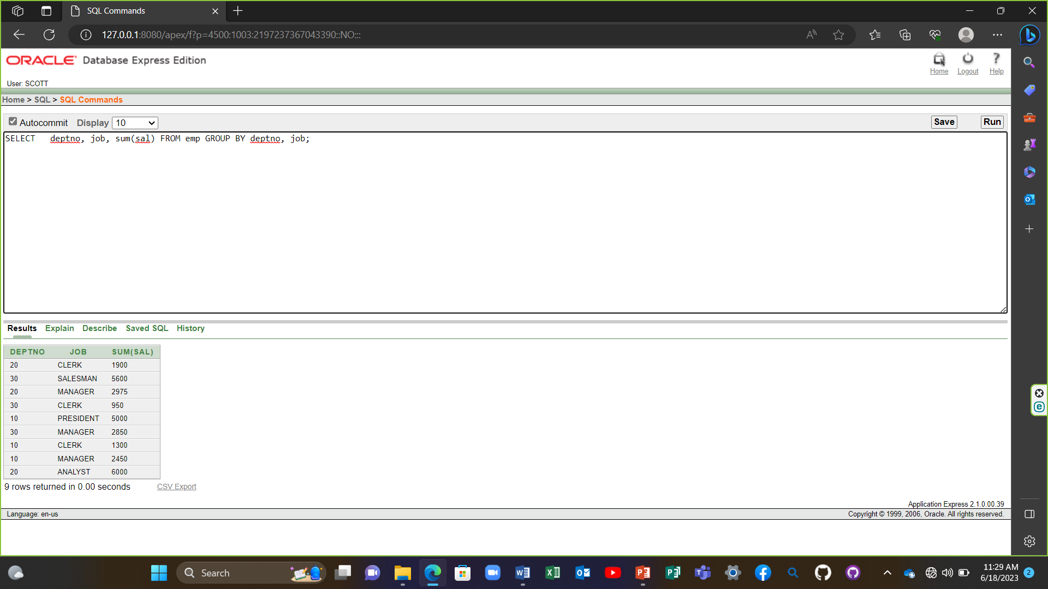

10) SELECT deptno, max(sal) FROM emp GROUP BY deptno HAVING max(sal)>2900;

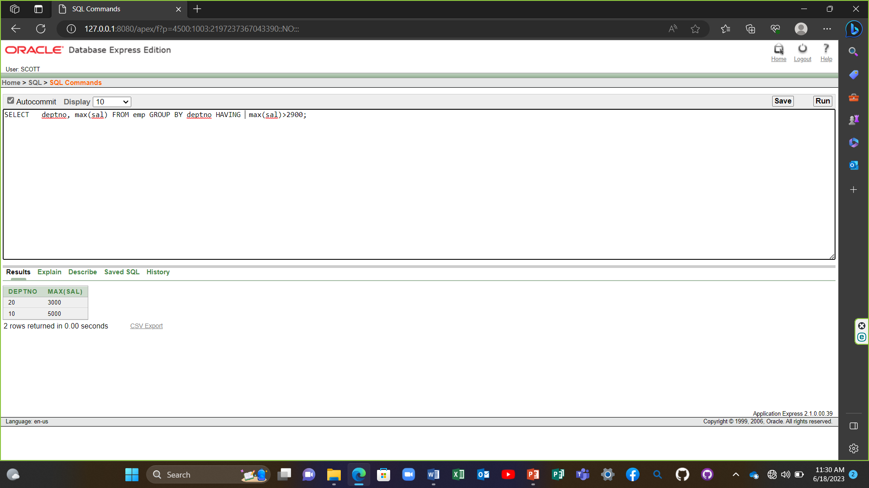

11) SELECT job, SUM(sal) PAYROLL FROM emp WHERE job NOT LIKE 'SALES%' GROUP BY job HAVING SUM(sal)>5000 ORDER BY SUM(sal);

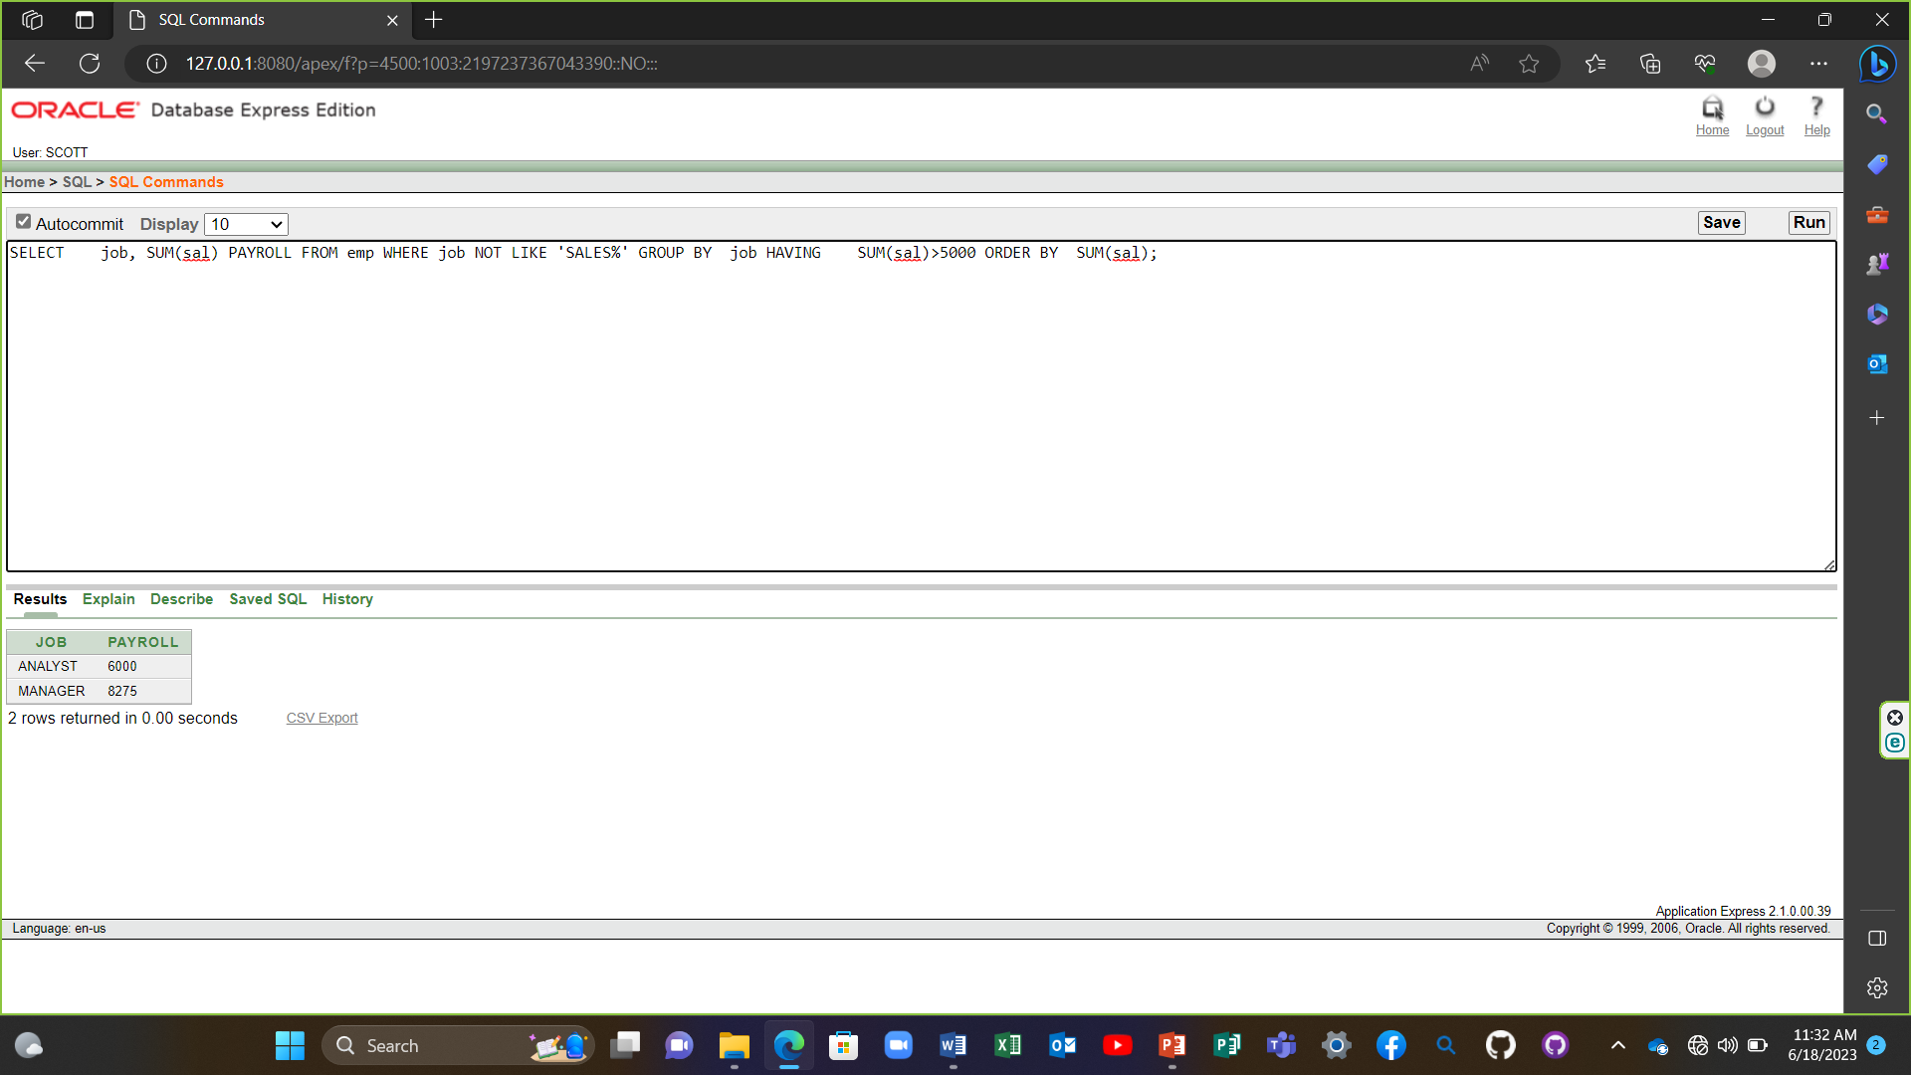

12) SELECT max(avg(sal)) FROM emp GROUP BY deptno;

